**Pratik Gupta**

**Complex MongDB Assignment**

Mongo DB Exercises - With the Restaurants Data Set

1. Download the restaurants.zip file

2. Unzip the file, you will see restaurants.json file

3. Run the mongod server

4. Run the following command to import the json file provided. It will load the

json file into the mongodb with database name - restaurants, collections

name - addresses

mongoimport --db restaurants --collection addresses --file restaurants.json

5. Run mongo shell command

6. show databases

7. use restaurants

8. db.addresses.find() should print entire json data

9. Then start working on the following exercises and submit your queries as the

Answers to the questions

Query Reference Links and Cheat sheets

1. https://docs.mongodb.com/manual/crud/

Exercise Questions

1. Write a MongoDB query to display all the documents in the collection restaurants.

2. Write a MongoDB query to display the fields restaurant_id, name, borough and cuisine for all the documents in the collection restaurant.



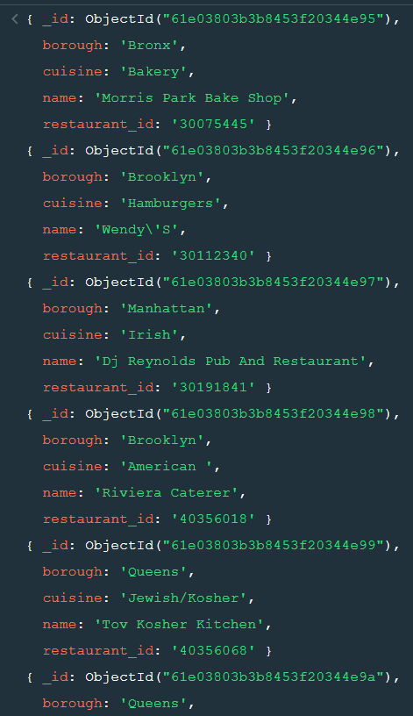

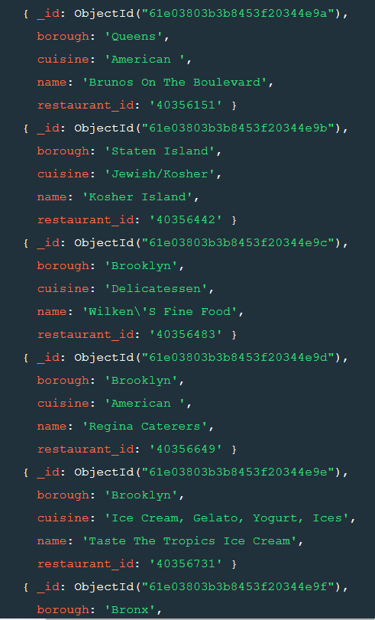

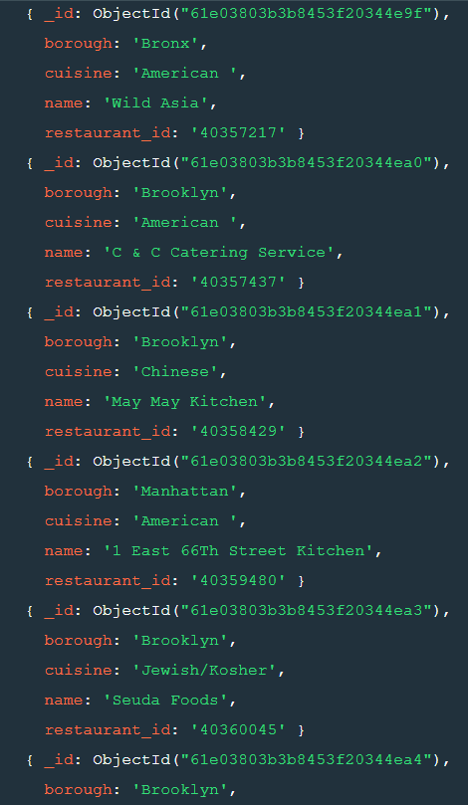

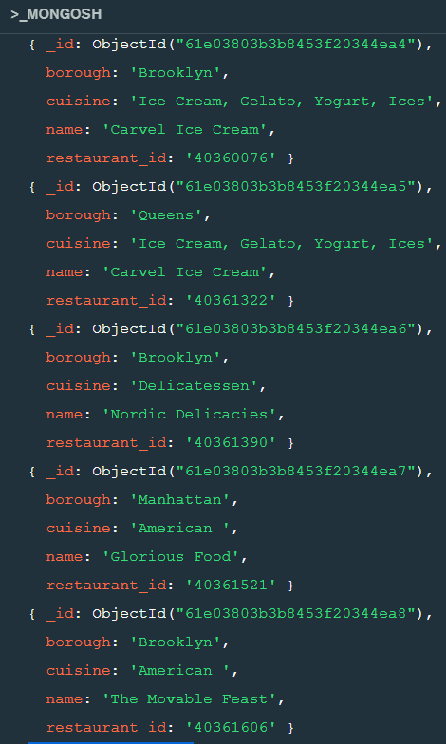

3. Write a MongoDB query to display the fields restaurant_id, name, borough and cuisine, but exclude the field _id for all the documents in the collection restaurant.

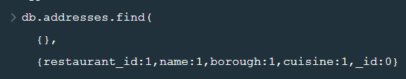

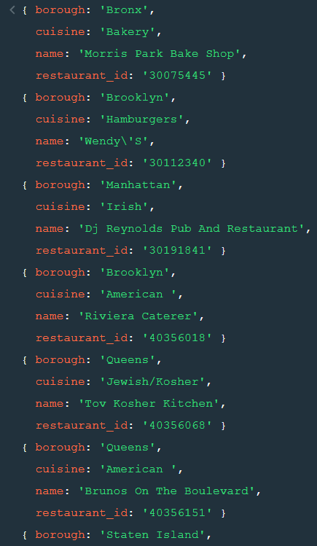

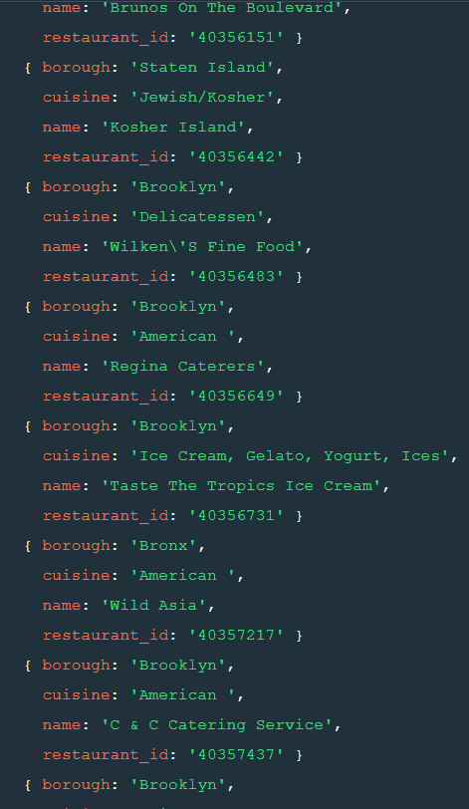

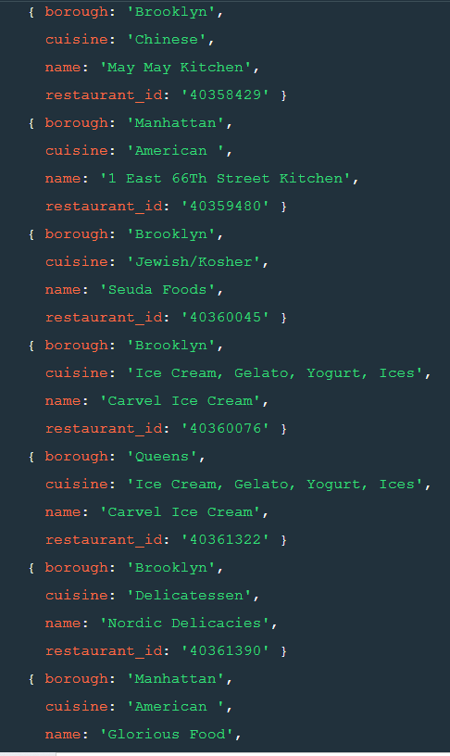

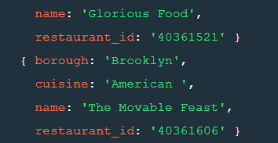

4. Write a MongoDB query to display the fields restaurant_id, name, boroughand zip code, but exclude the field _id for all the documents in the collection restaurant.

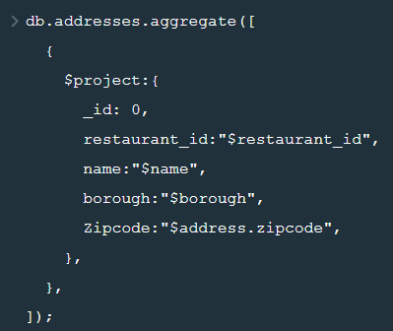

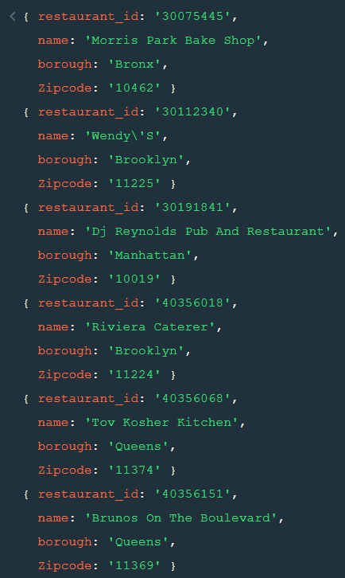

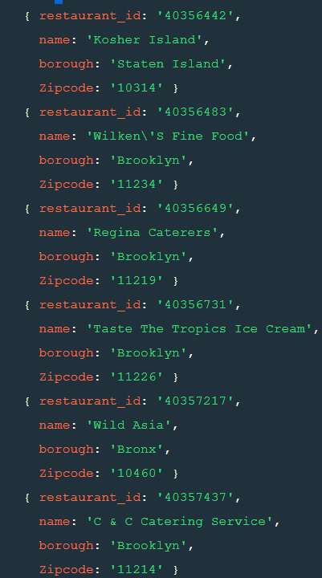

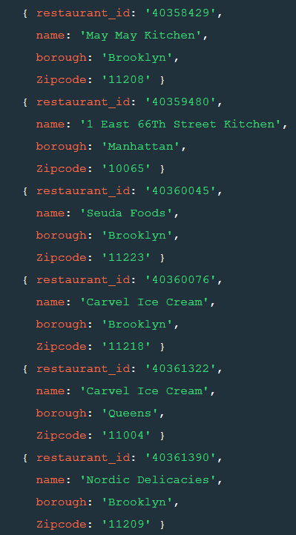

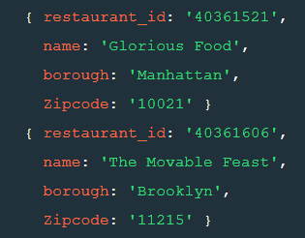

5. Write a MongoDB query to display the first 5 restaurant which is in the borough Bronx.

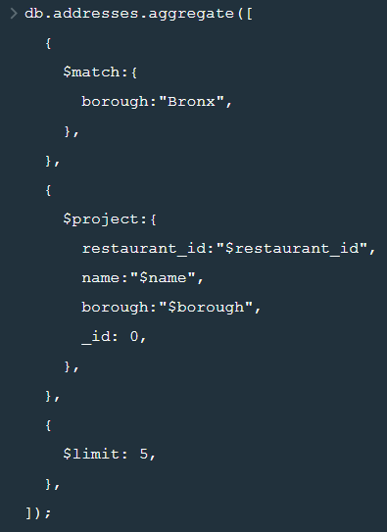

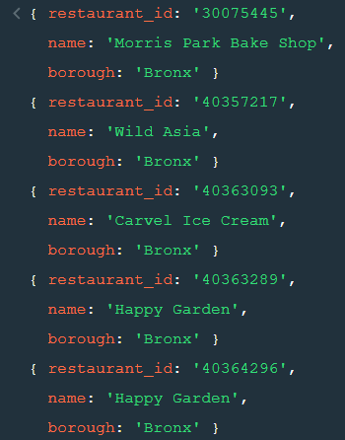

6. Write a MongoDB query to display all the restaurant which is in the borough Bronx.

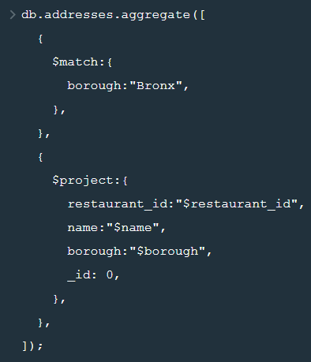

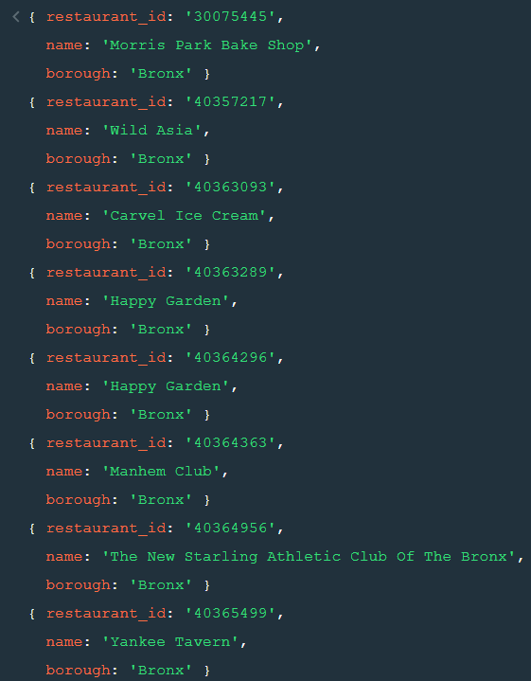

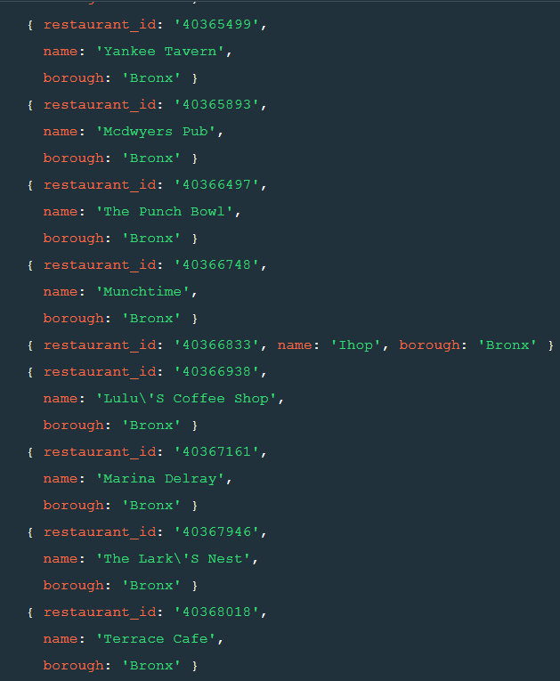

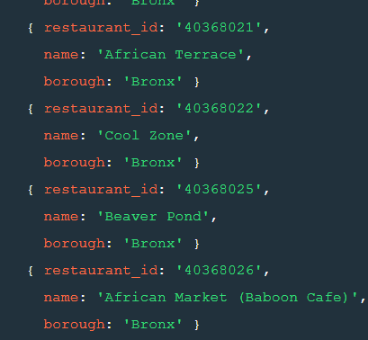

7. Write a MongoDB query to display the next 5 restaurants after skipping first 5 which are in the borough Bronx.



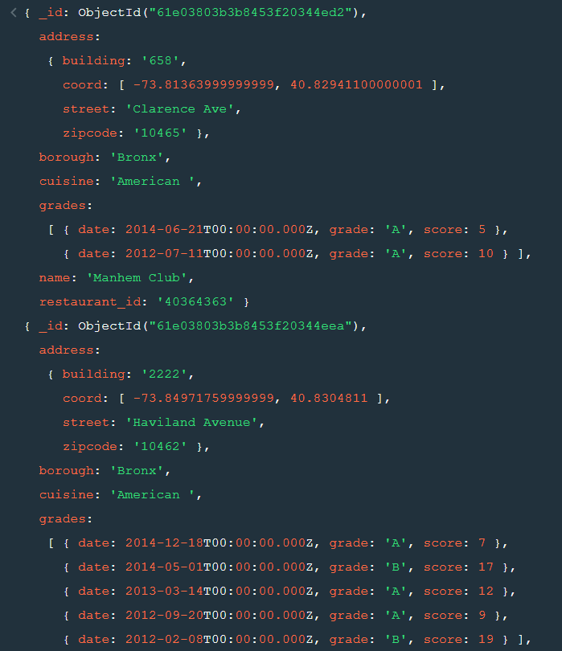

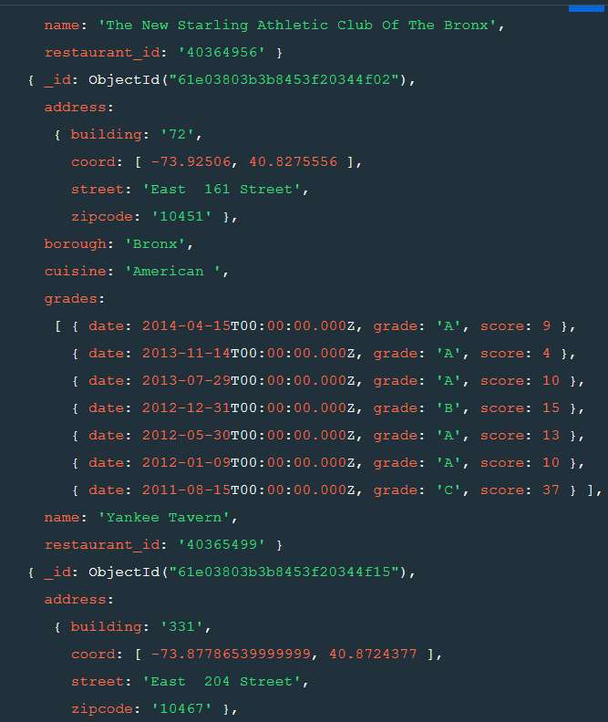

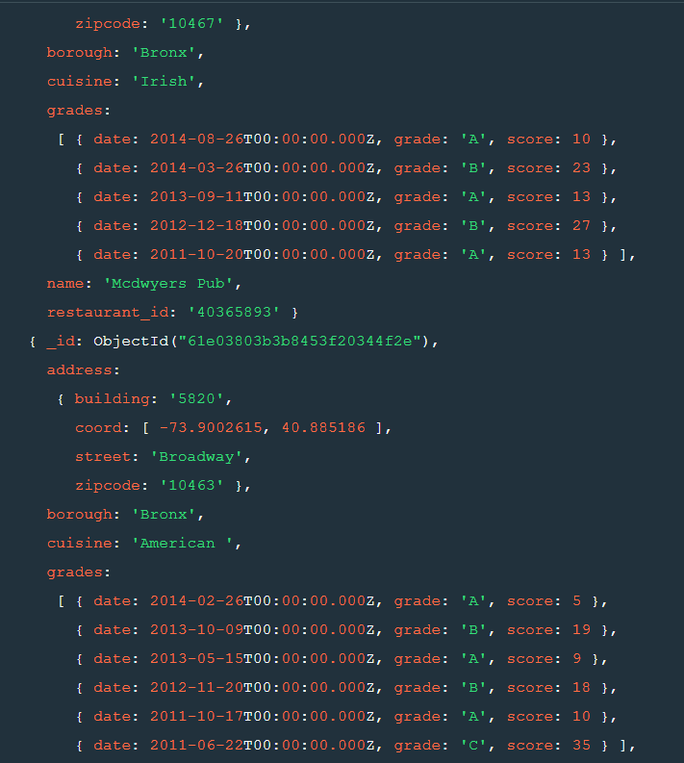

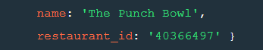

8. Write a MongoDB query to find the restaurants who achieved a score more

than 90.

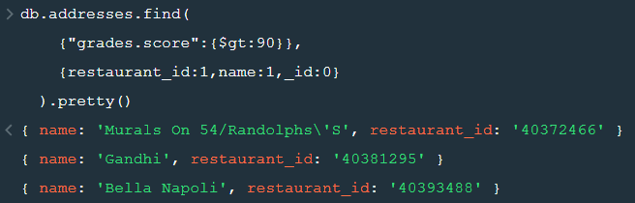

9. Write a MongoDB query to find the restaurants that achieved a score, more than 80 but less than 100.

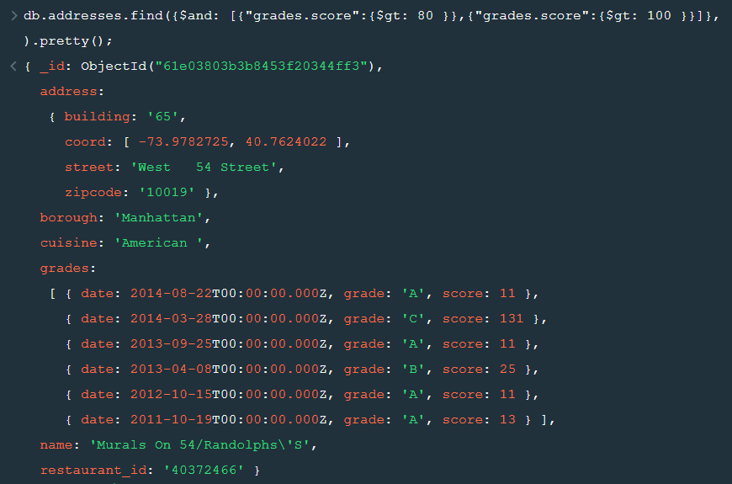

10. Write a MongoDB query to find the restaurants which locate in latitude value less than -95.754168.



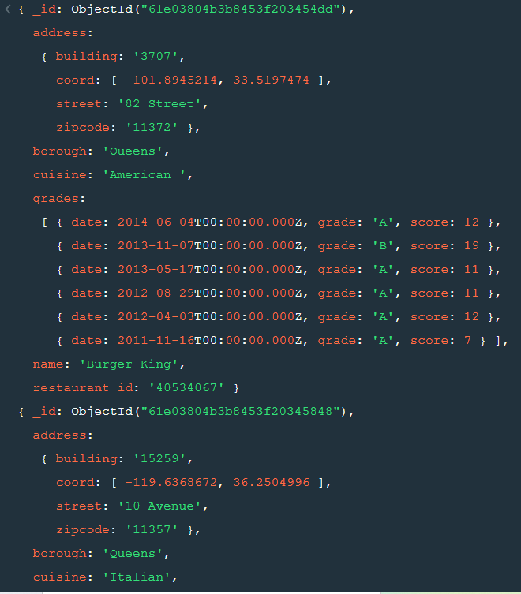

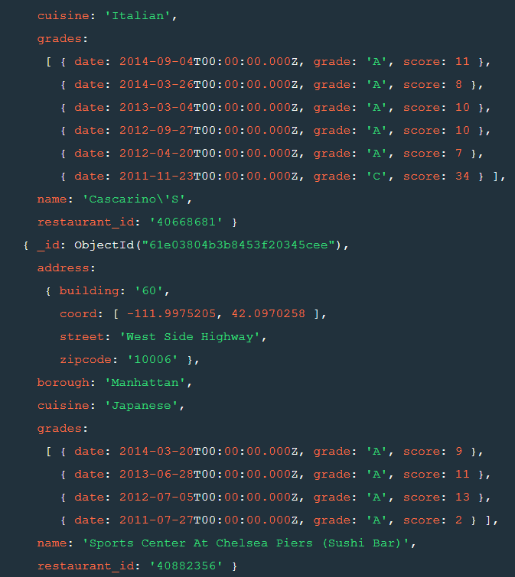

11. Write a MongoDB query to find the restaurants that do not prepare any cuisine of 'American' and their grade score more than 70 and latitude less than -65.754168.

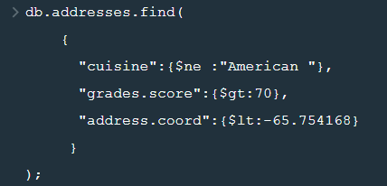

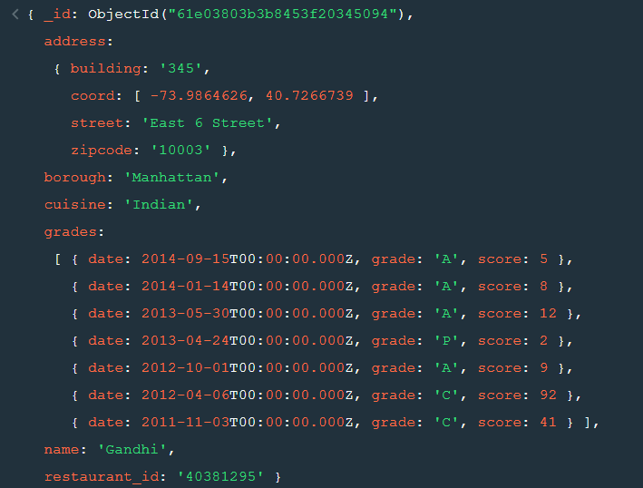

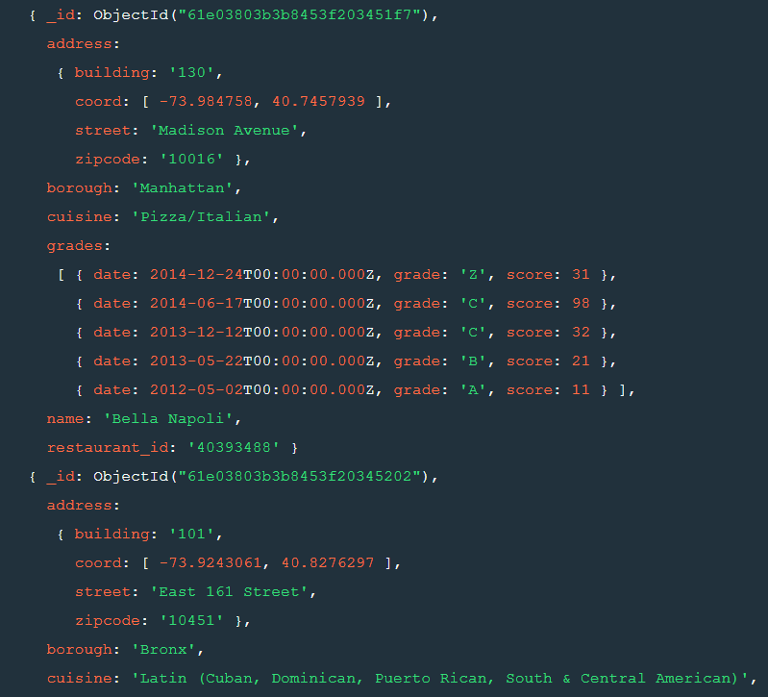

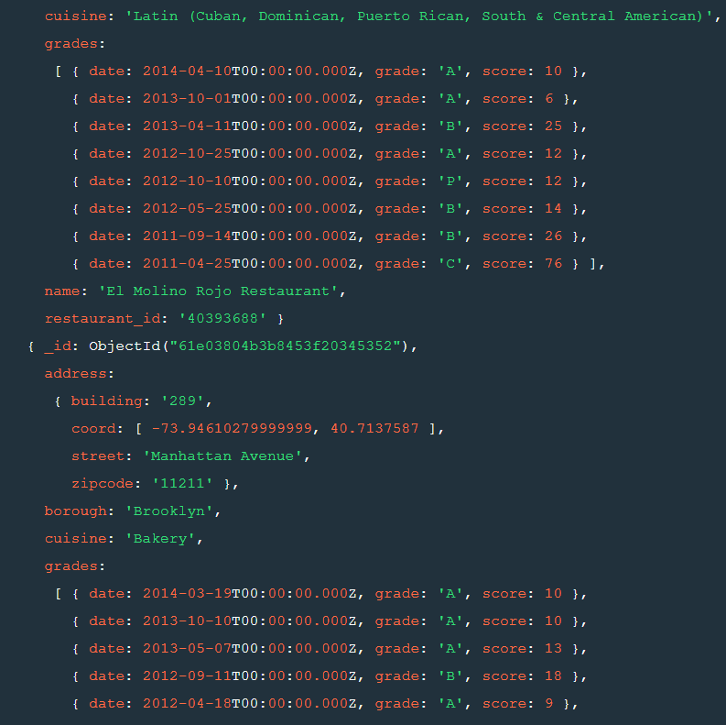

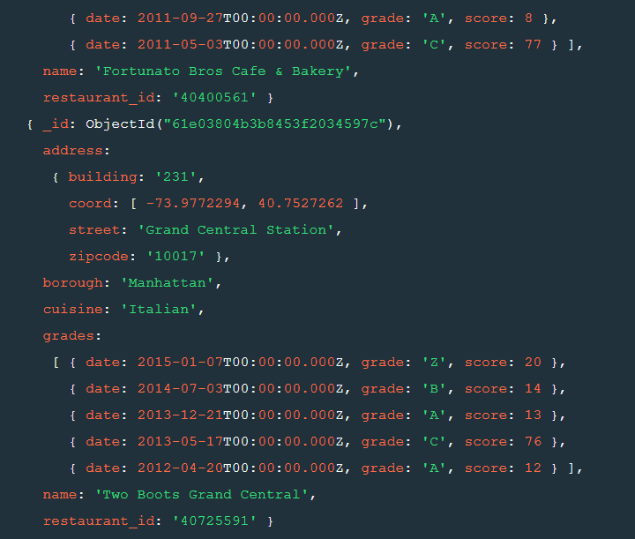

12. Write a MongoDB query to find the restaurants which do not prepare any cuisine of 'American' and achieved a score more than 70 and located in the longitude less than -65.754168.

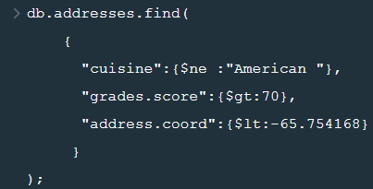

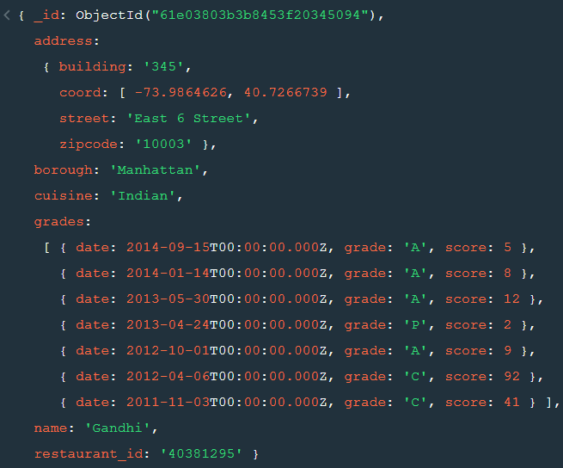

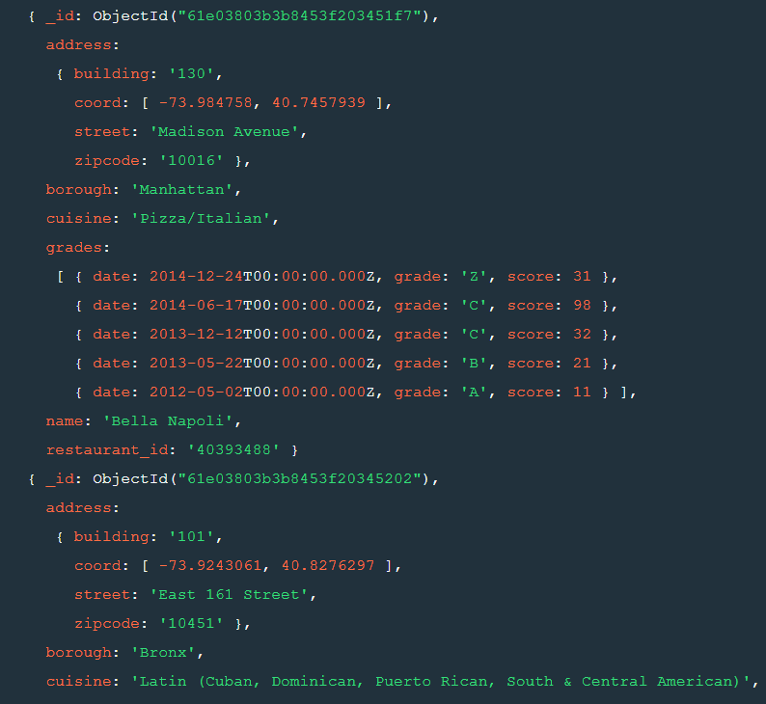

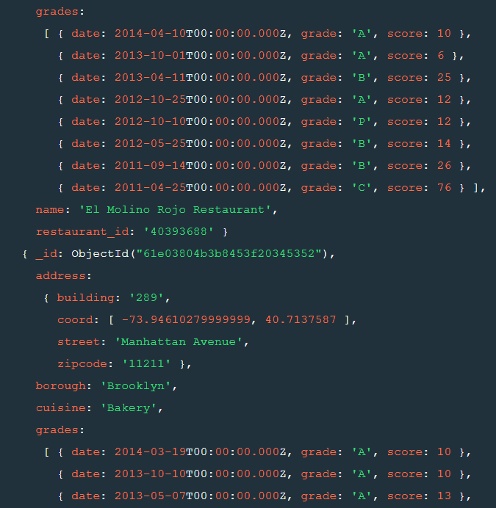

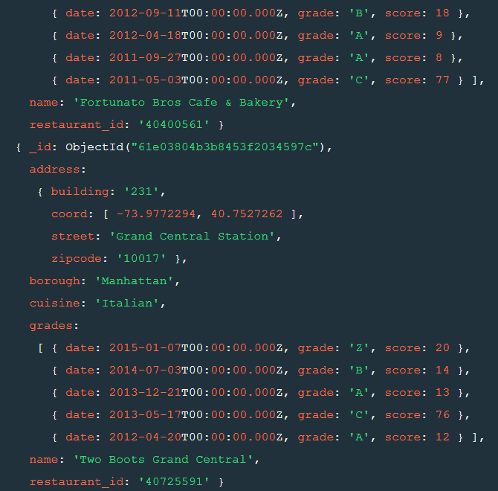

13. Write a MongoDB query to find the restaurants which do not prepare any cuisine of 'American ' and achieved a grade point 'A' not belongs to the borough Brooklyn. The document must be displayed according to the cuisine in descending order.

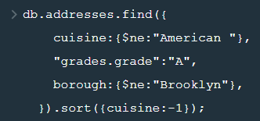

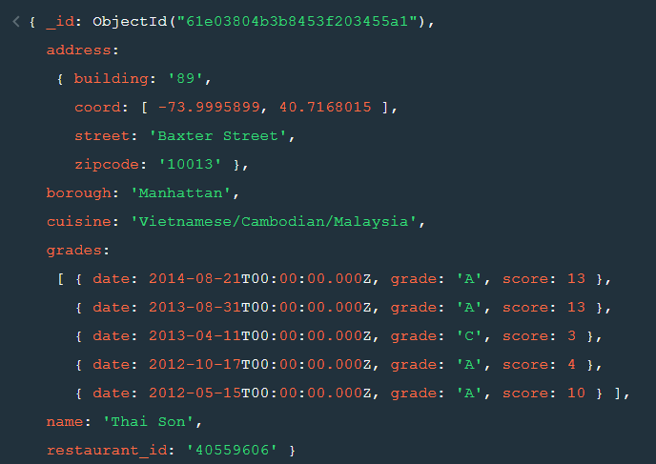

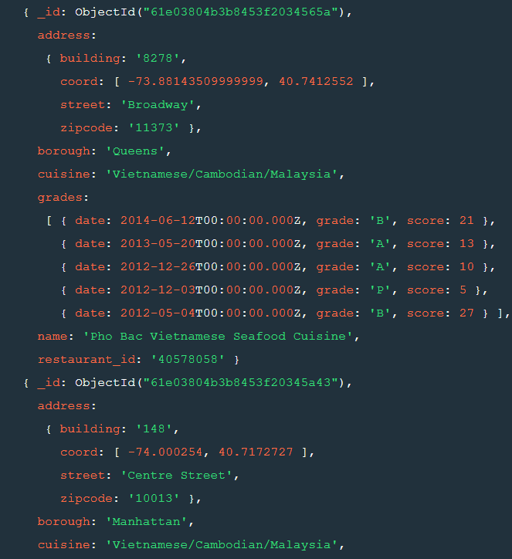

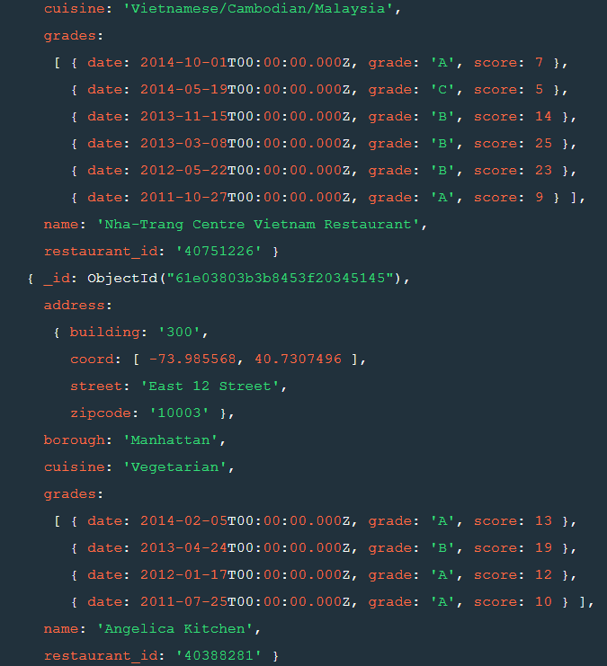

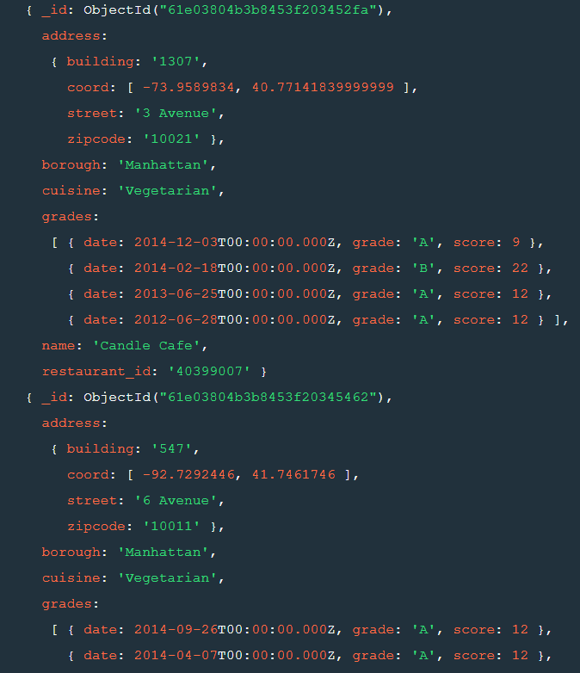

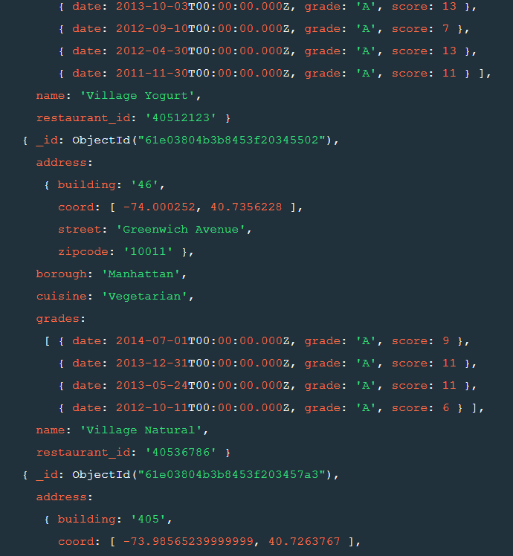

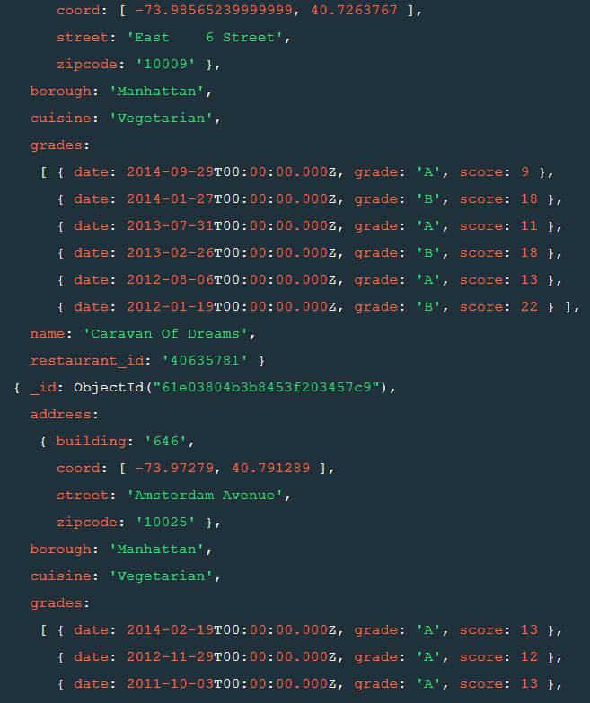

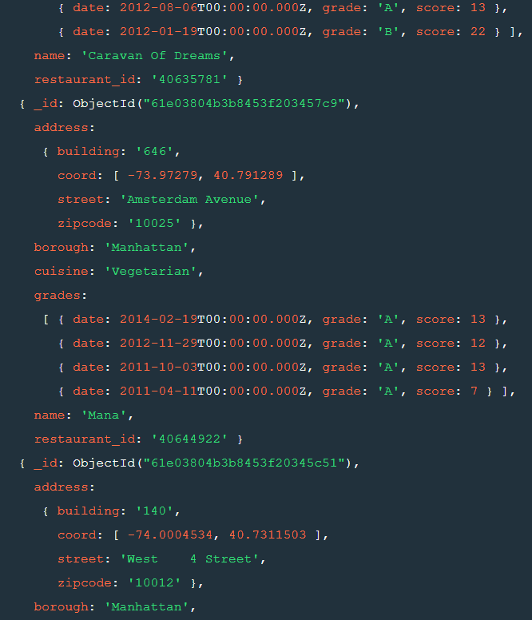

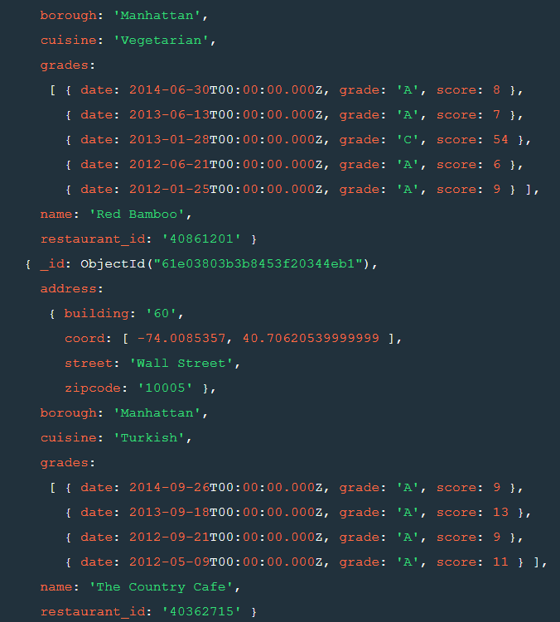

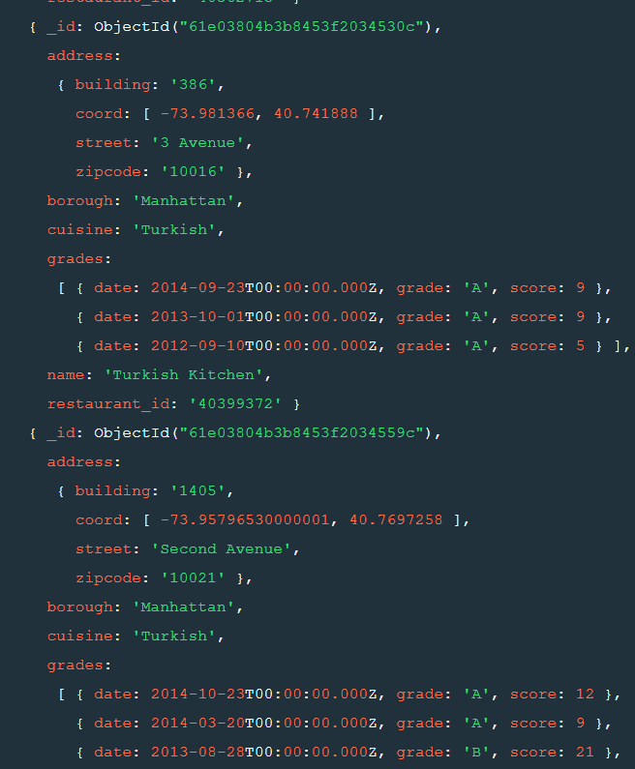

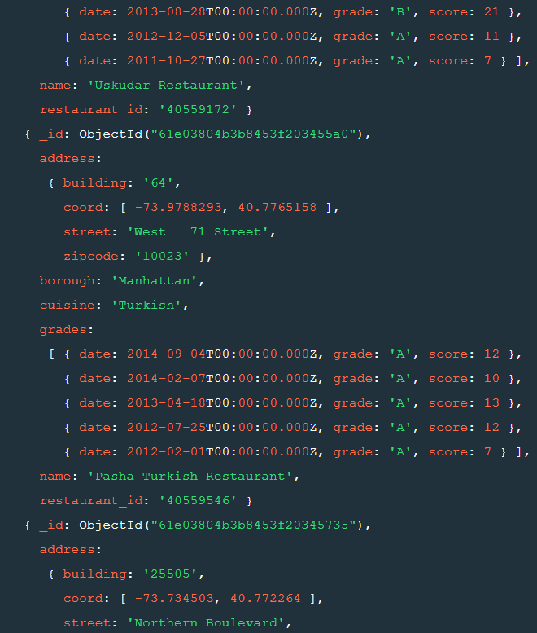

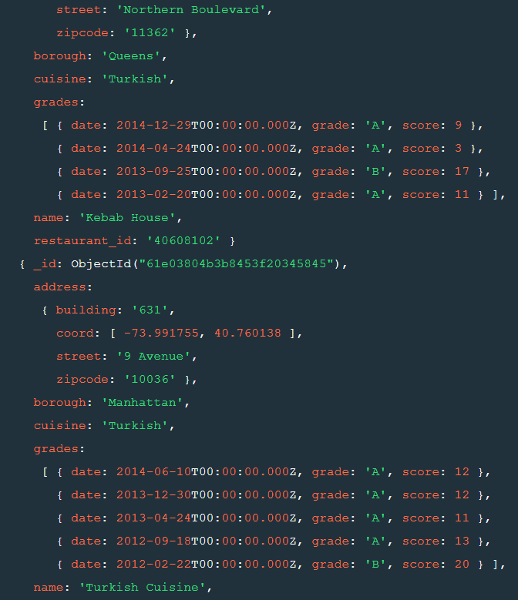  
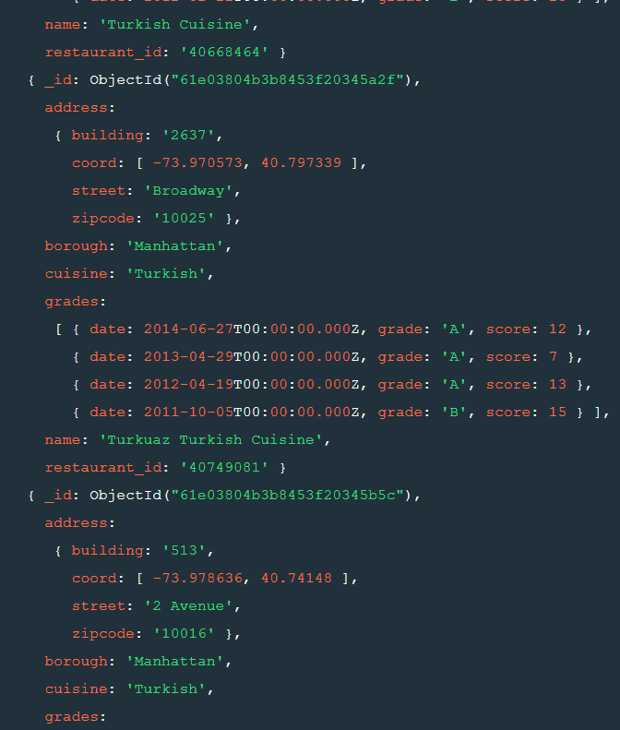

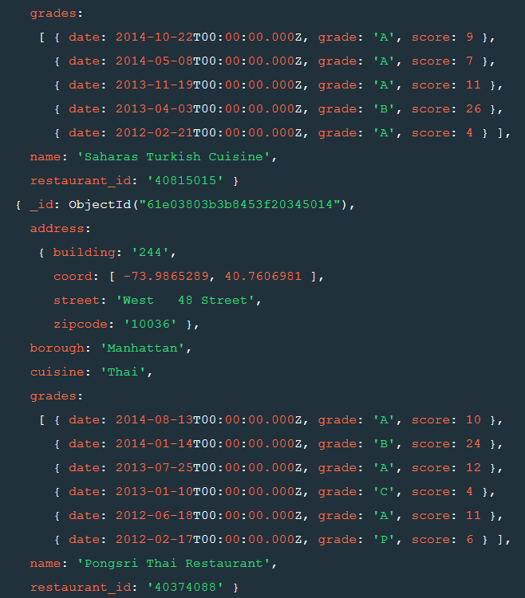 

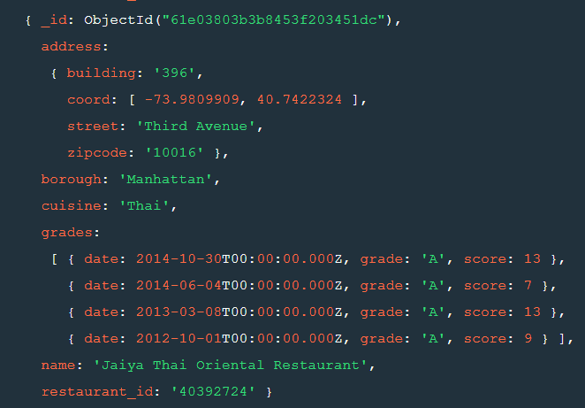

14. Write a MongoDB query to find the restaurant Id, name, borough and cuisine for those restaurants which contain 'Wil' as first three letters for its name.

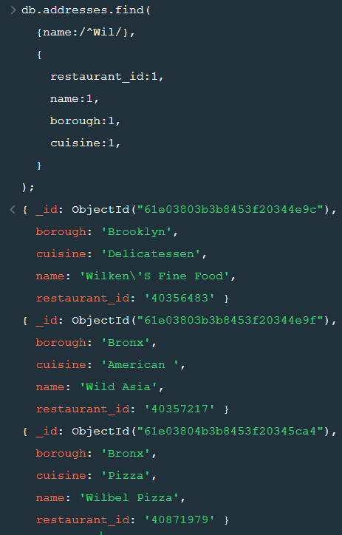

15. Write a MongoDB query to find the restaurant Id, name, borough and cuisine for those restaurants which contain 'ces' as last three letters for its name.

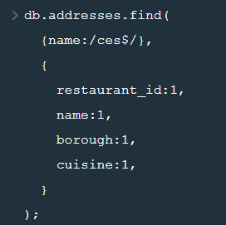

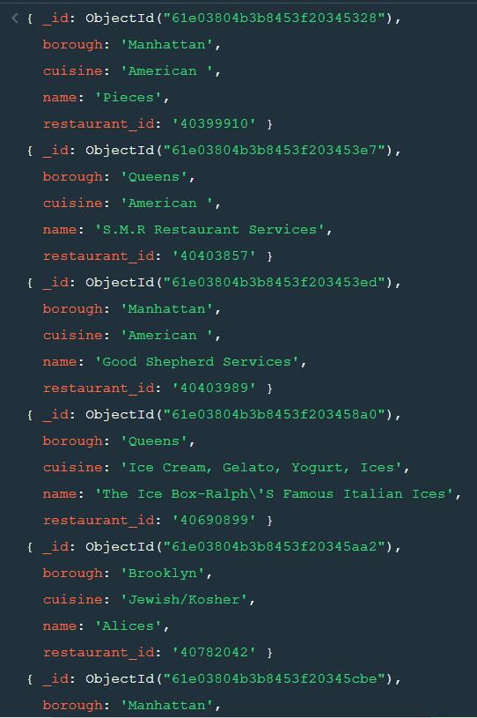

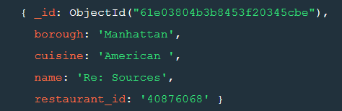

16. Write a MongoDB query to find the restaurant Id, name, borough and cuisine for those restaurants which contain 'Reg' as three letters somewhere in its name.

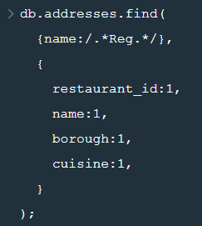

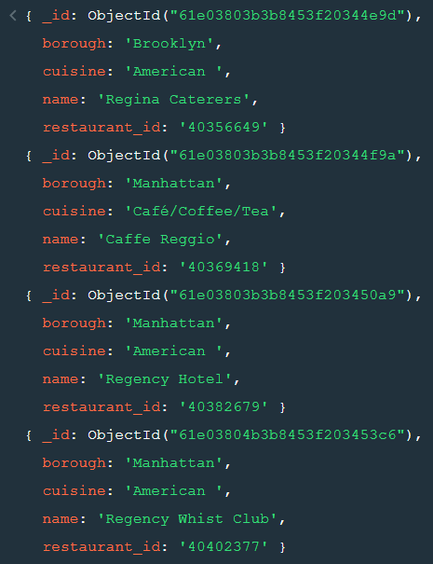

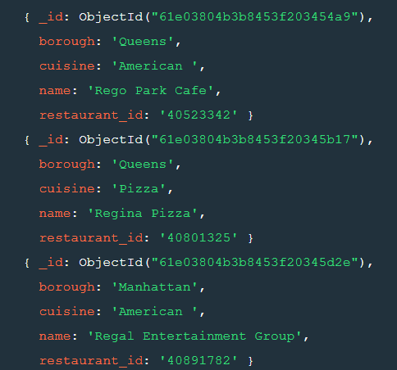

17. Write a MongoDB query to find the restaurants which belong to the borough Bronx and prepared either American or Chinese dish.

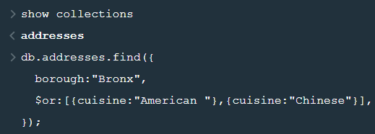

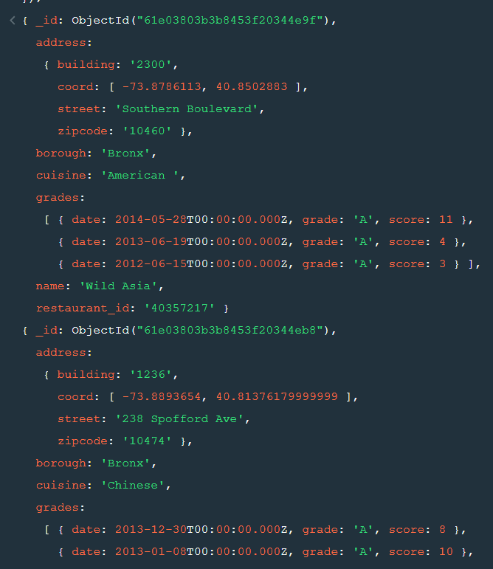

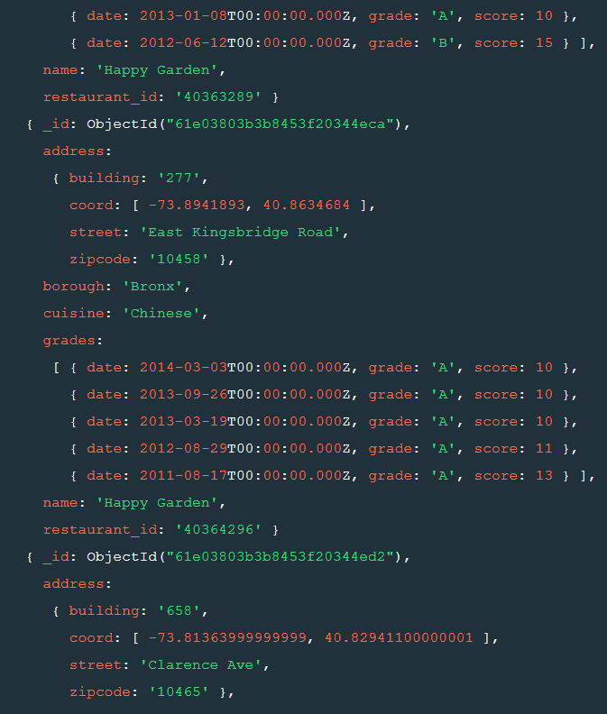

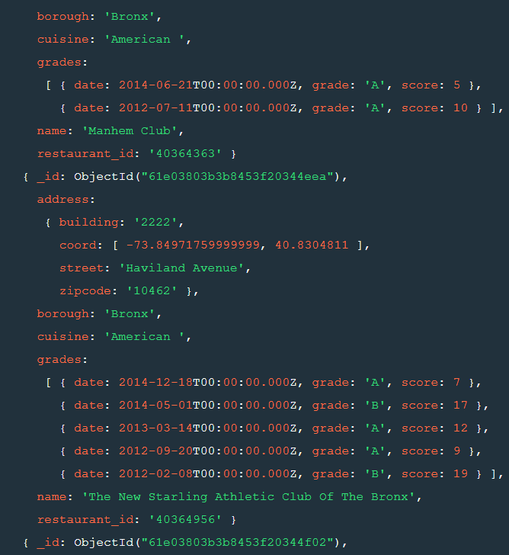

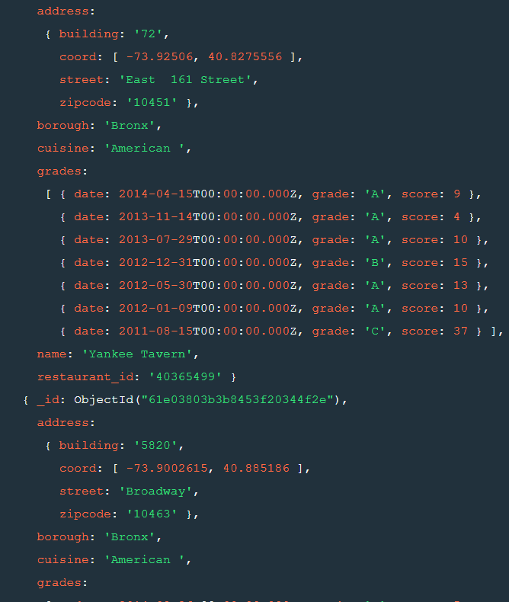

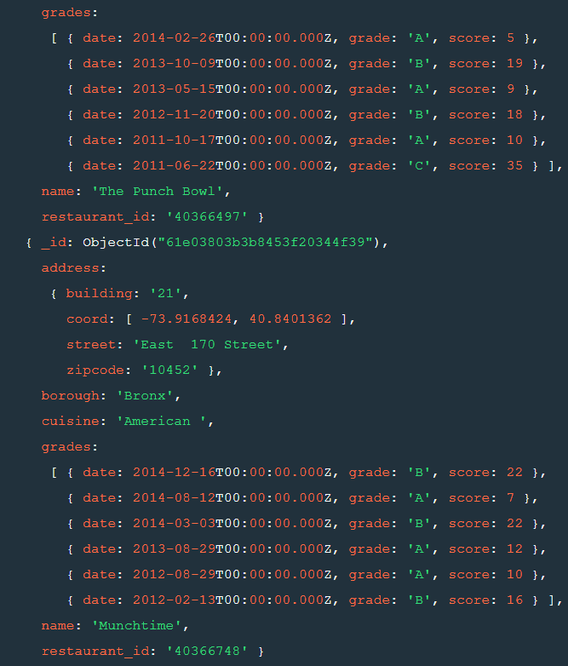

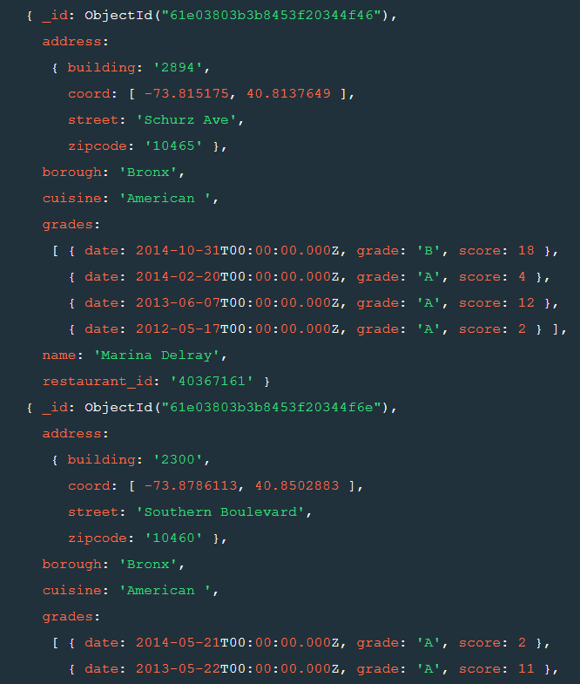

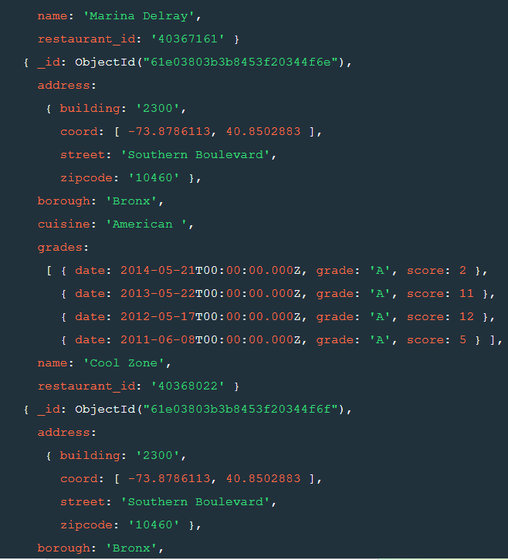

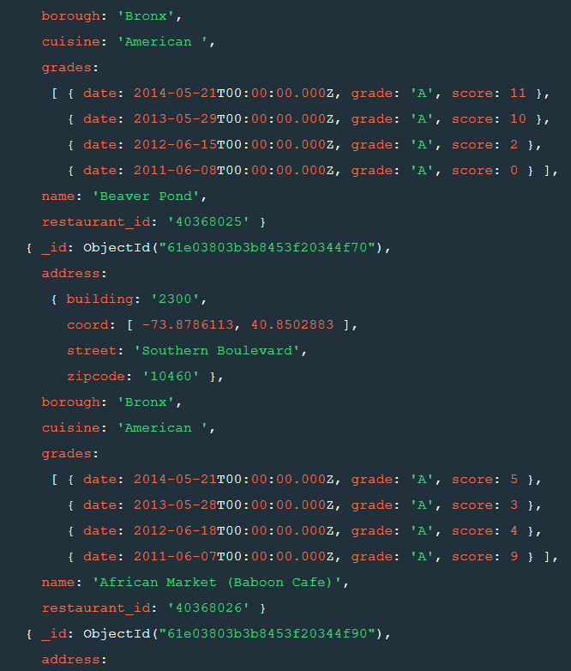

18. Write a MongoDB query to find the restaurant Id, name, borough and cuisine for those restaurants which belong to the borough Staten Island or Queens or Bronxor Brooklyn.

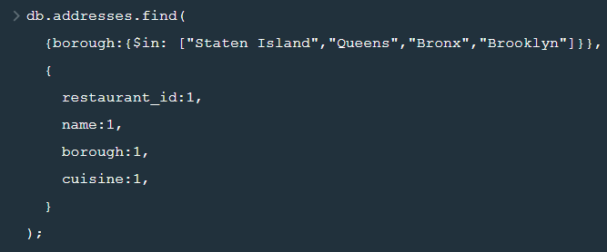

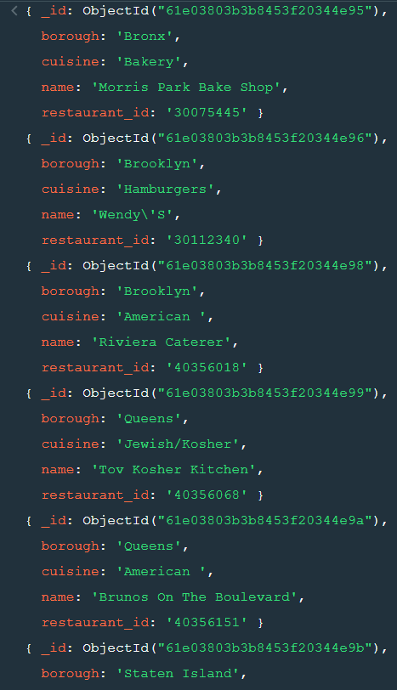

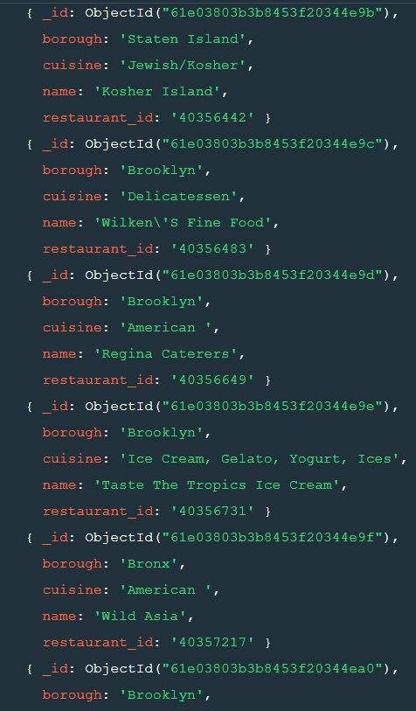

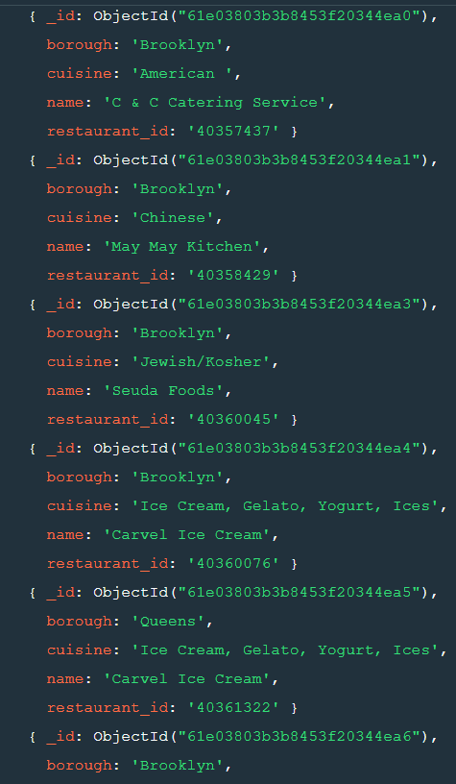

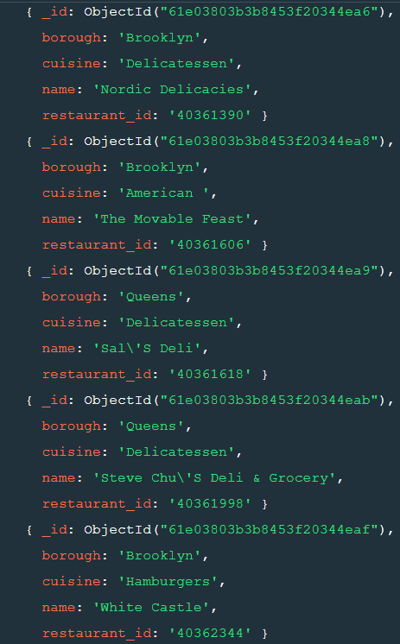

19. Write a MongoDB query to find the restaurant Id, name, borough and cuisine for those restaurants which are not belonging to the borough Staten Island or Queens or Bronxor Brooklyn.

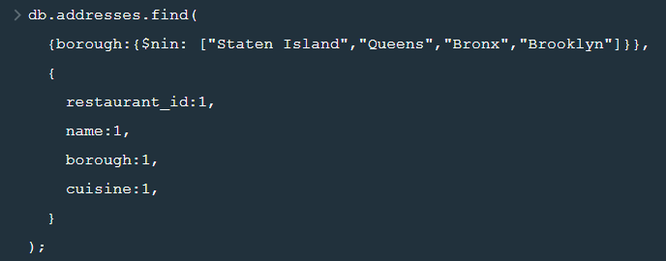

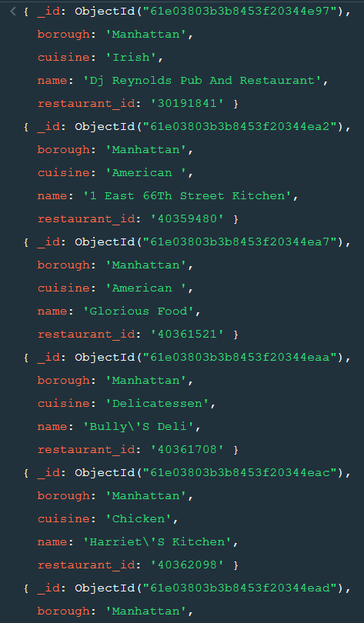

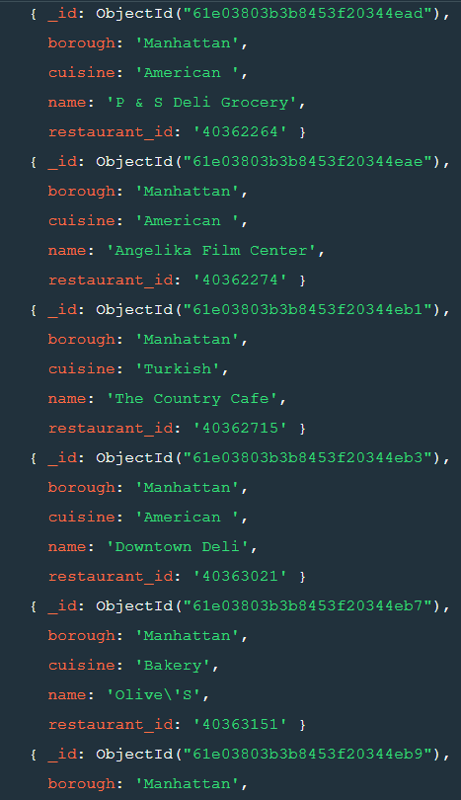

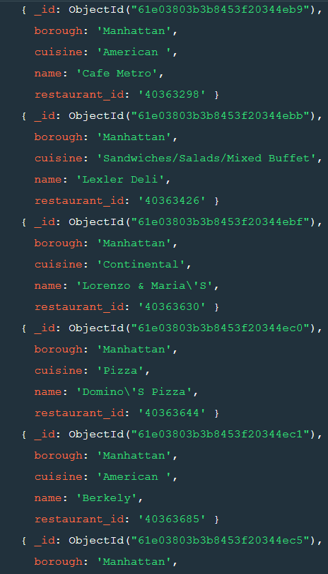

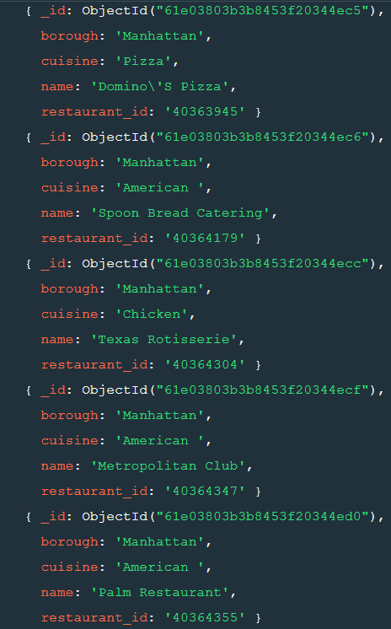

20. Write a MongoDB query to find the restaurant Id, name, borough and cuisine for those restaurants which achieved a score which is not more than 10.

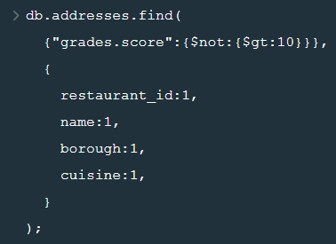

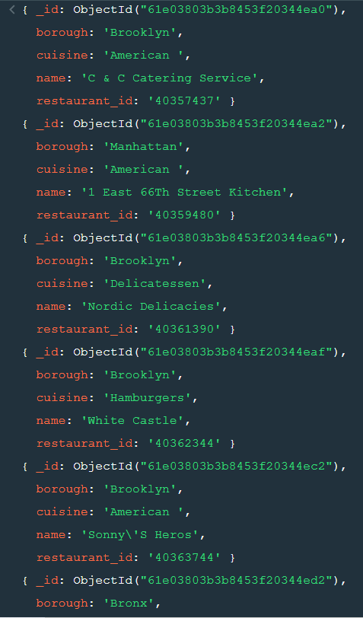

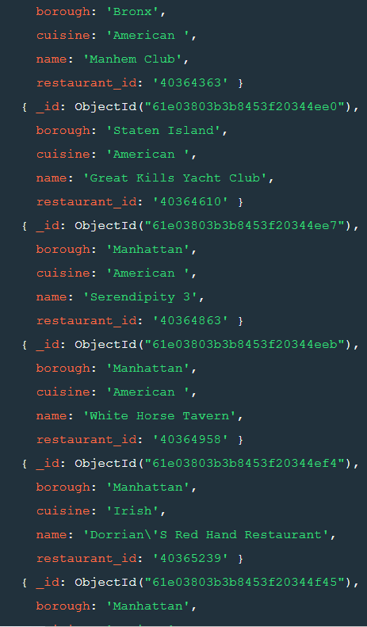

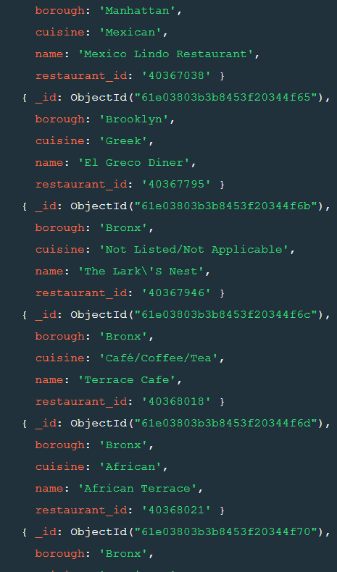

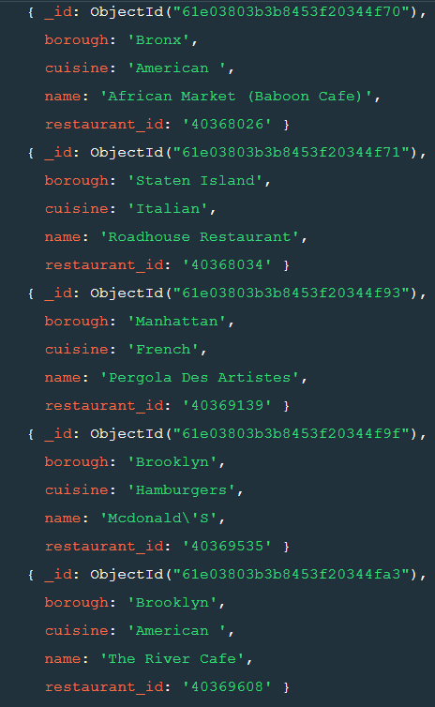

21. Write a MongoDB query to find the restaurant Id, name, borough and cuisine for those restaurants which prepared dish except 'American' and 'Chinees' or restaurant's name begins with letter 'Wil'.

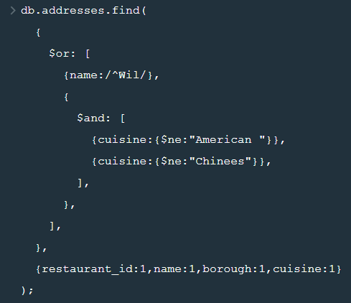

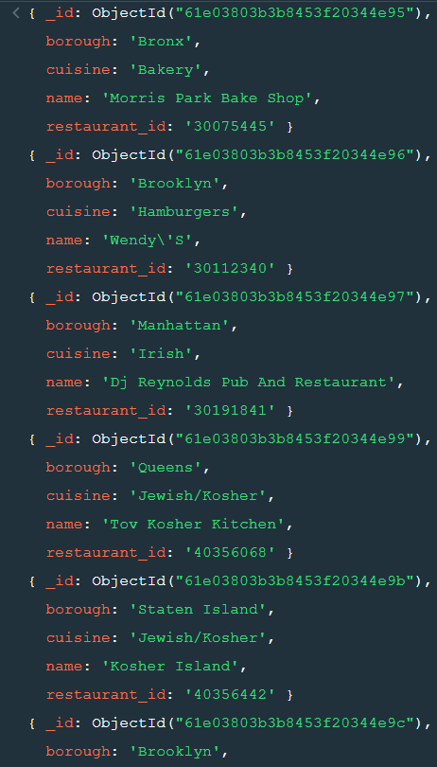

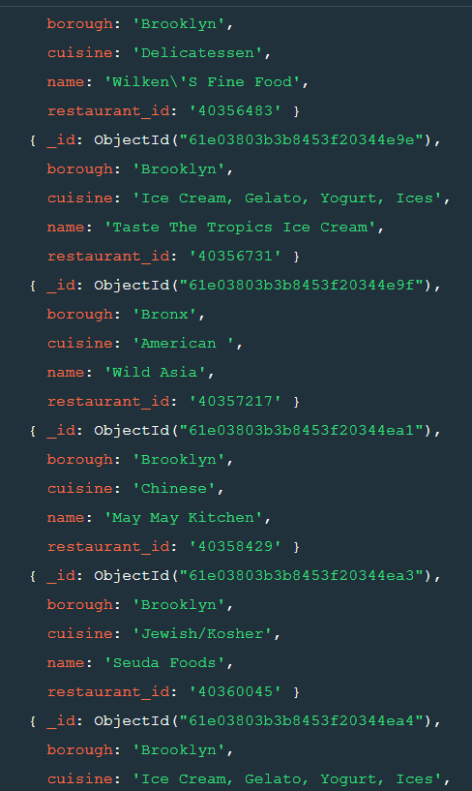

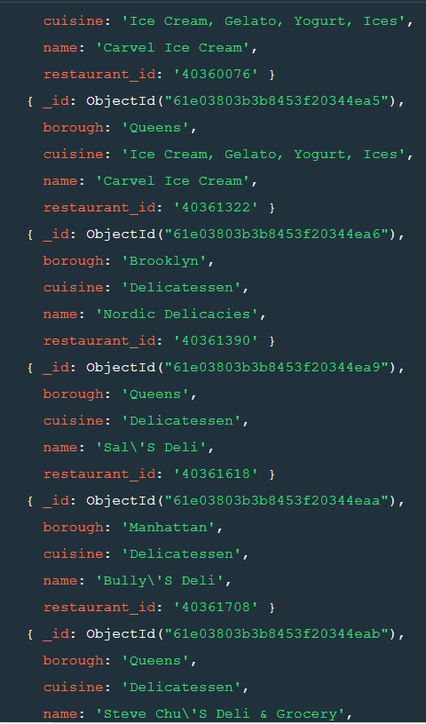

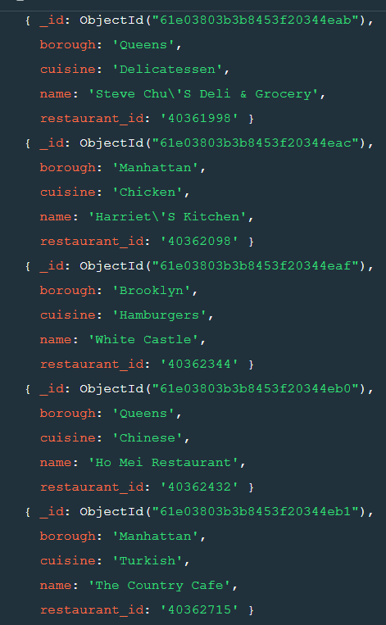

22. Write a MongoDB query to find the restaurant Id, name, and grades for those restaurants which achieved a grade of "A" and scored 11 on an ISO Date "2014-08-11T00:00:00Z" among many of survey dates.

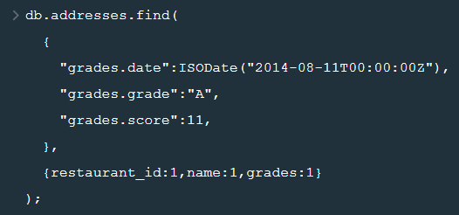

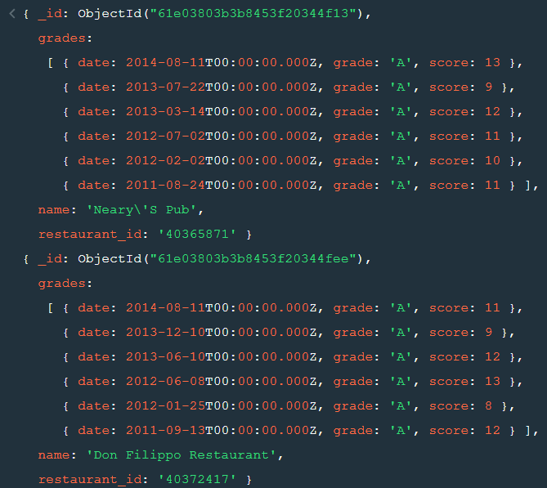

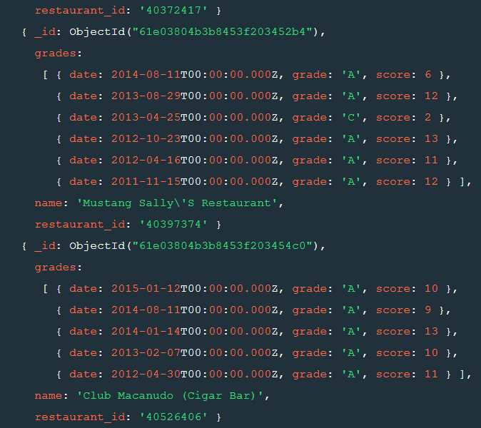

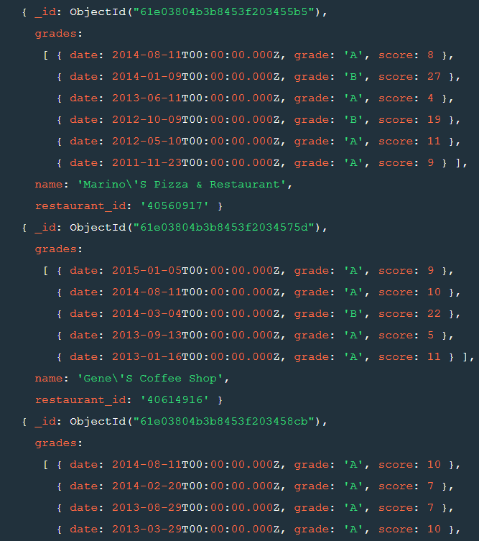

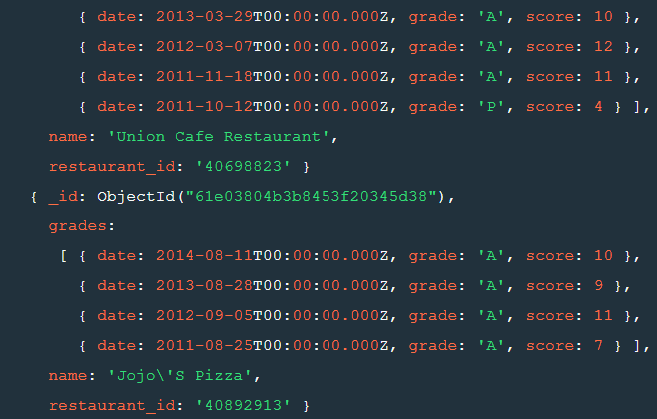

23. Write a MongoDB query to find the restaurant Id, name and grades for those restaurants where the 2nd element of grades array contains a grade of "A" and score 9 on an ISODate "2014-08-11T00:00:00Z"

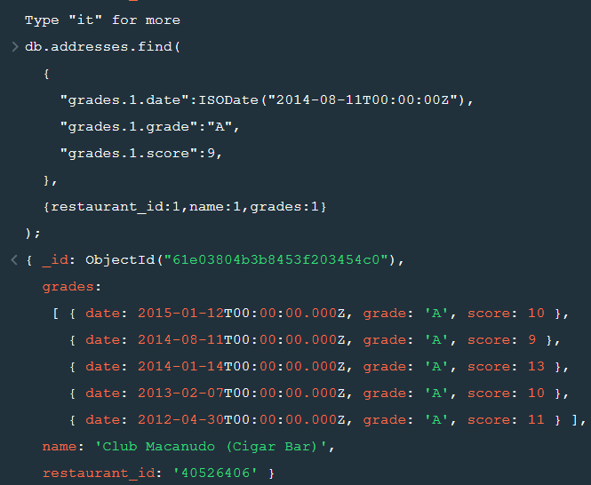

24. Write a MongoDB query to find the restaurant Id, name, address and geographical location for those restaurants where 2nd element of coord array contains a value which is more than 42 and upto 52.

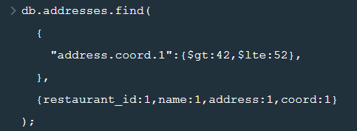

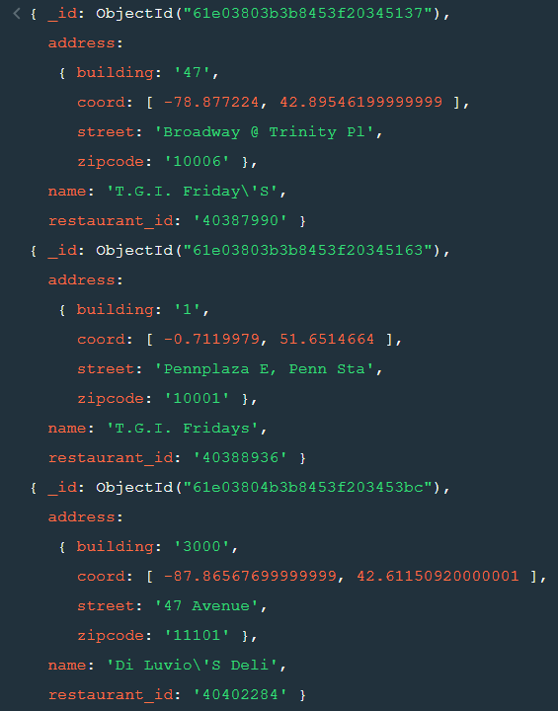

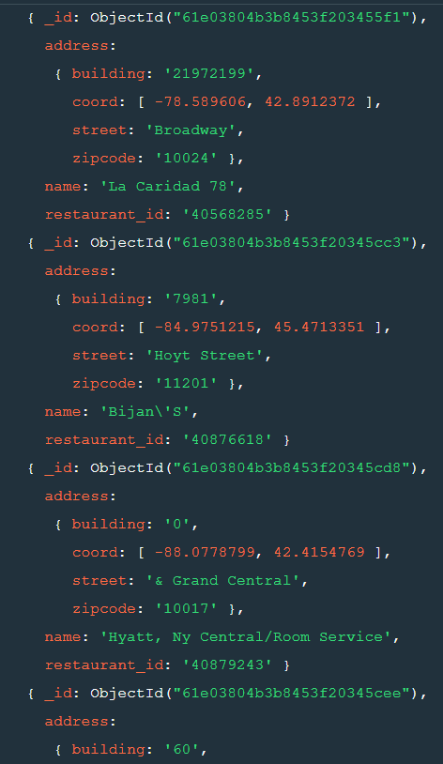

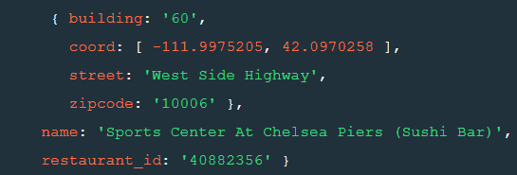

25. Write a MongoDB query to arrange the name of the restaurants in ascending order along with all the columns.



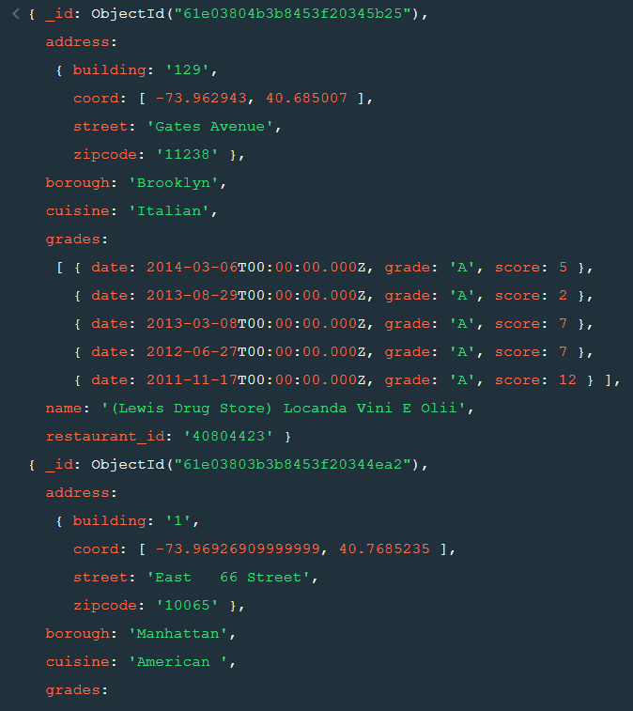

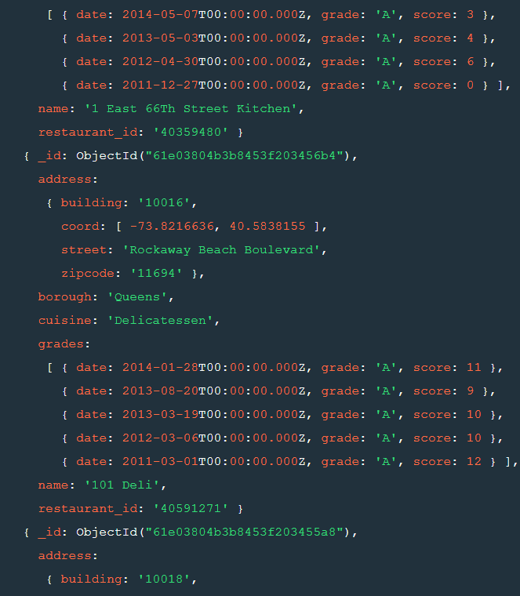

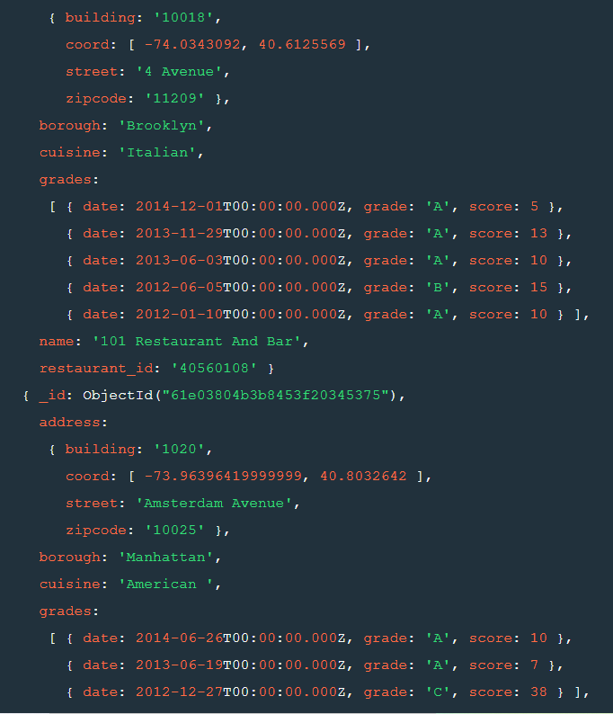

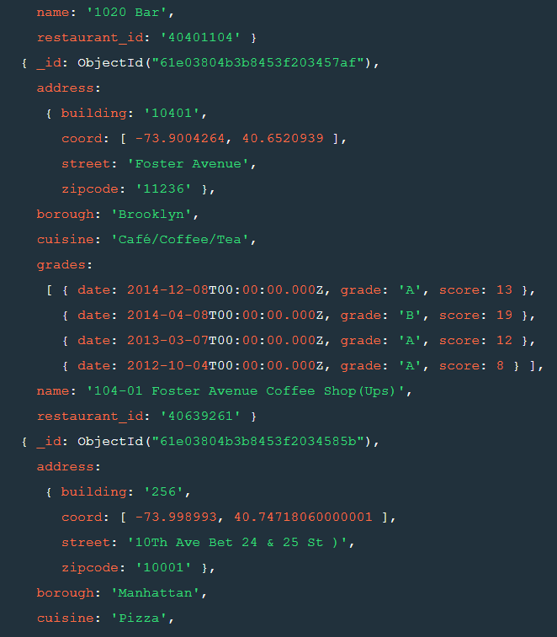

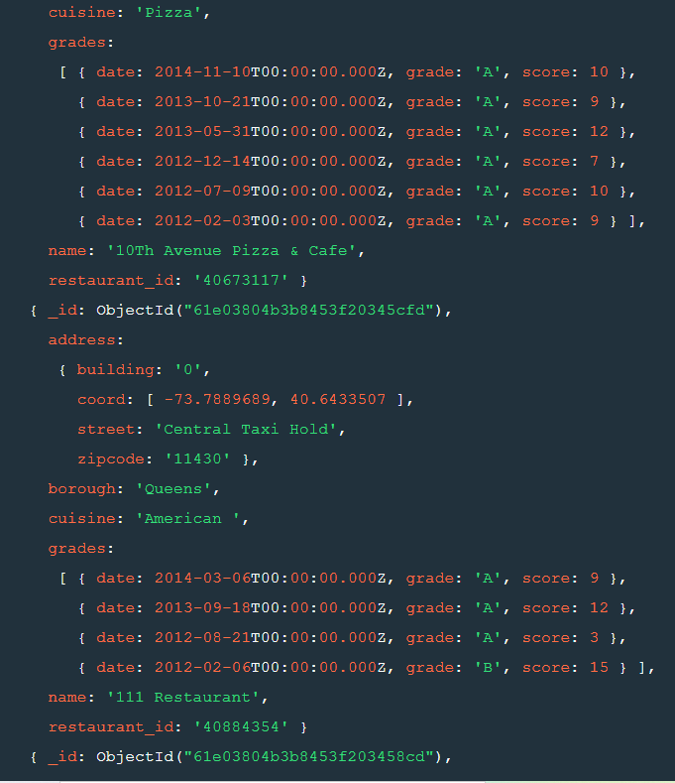

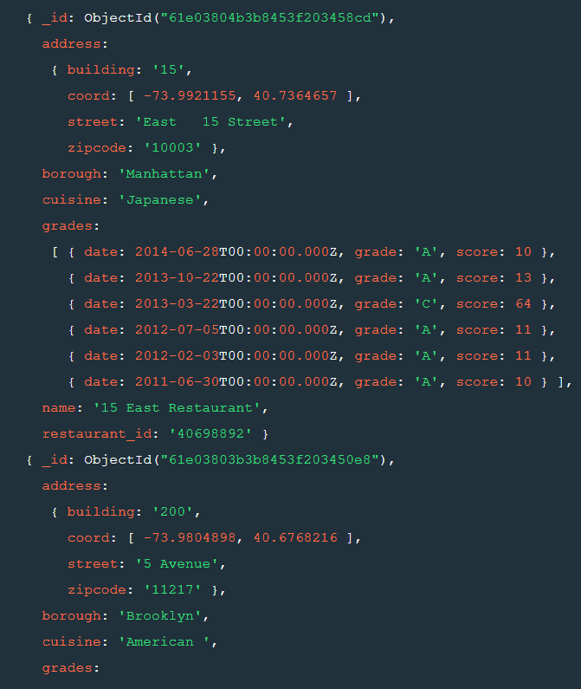

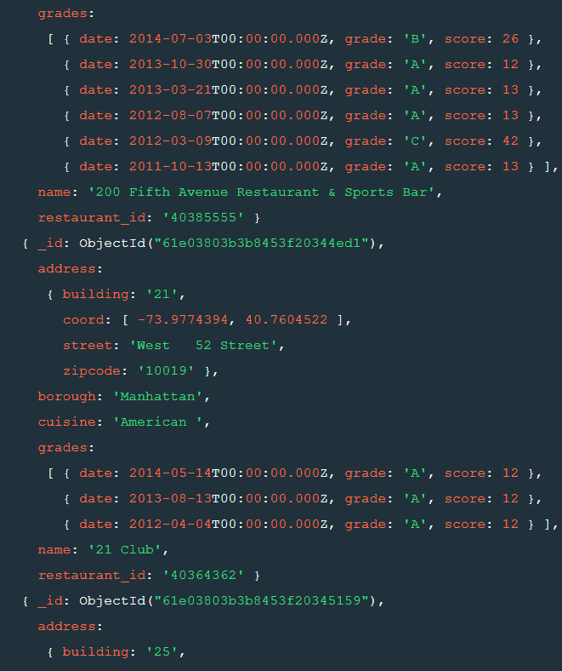

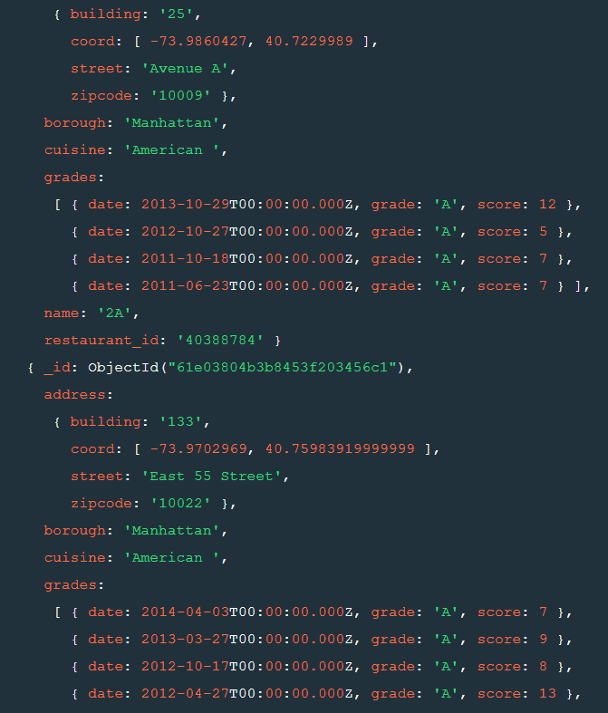

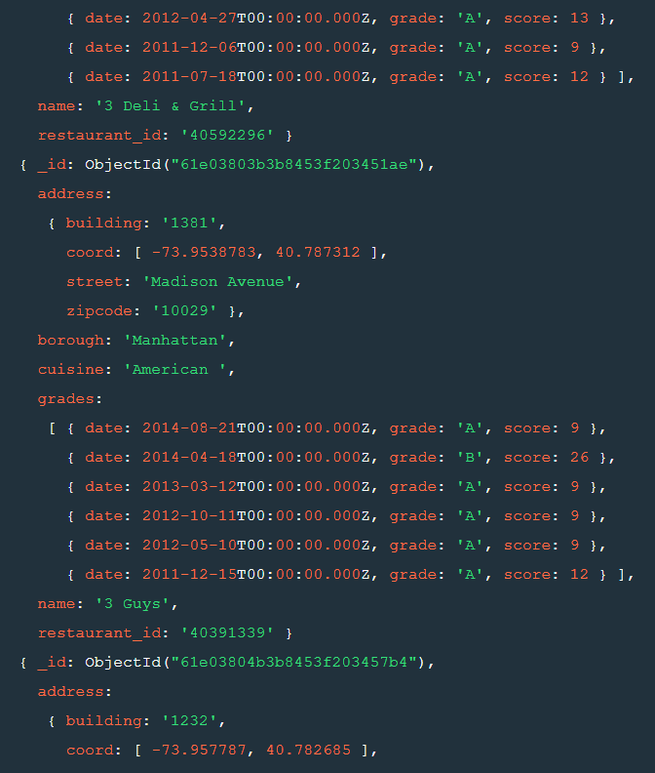



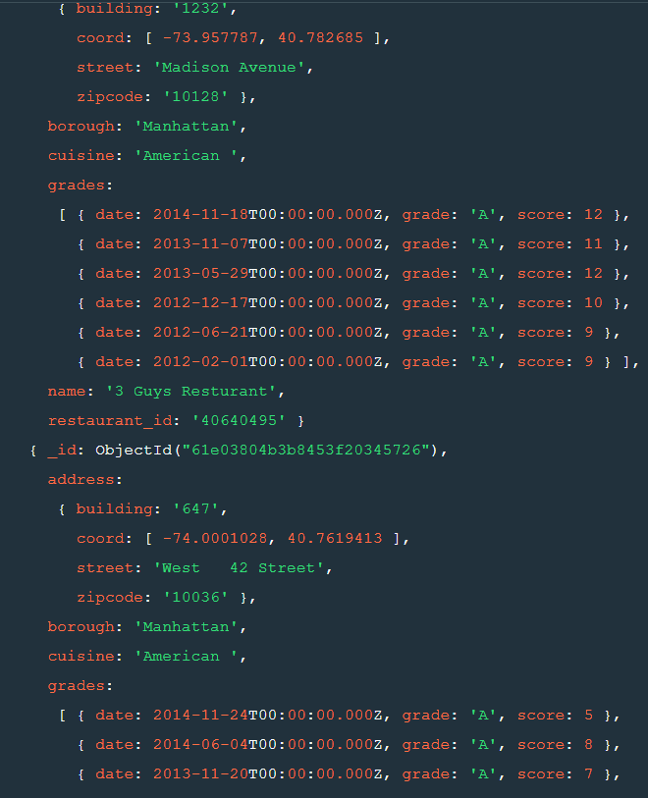

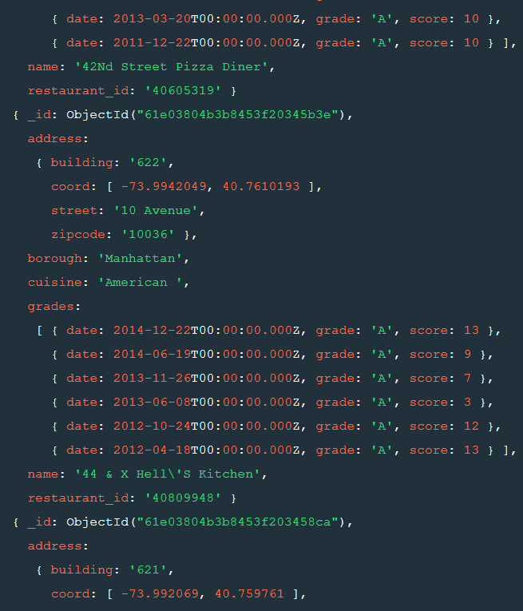

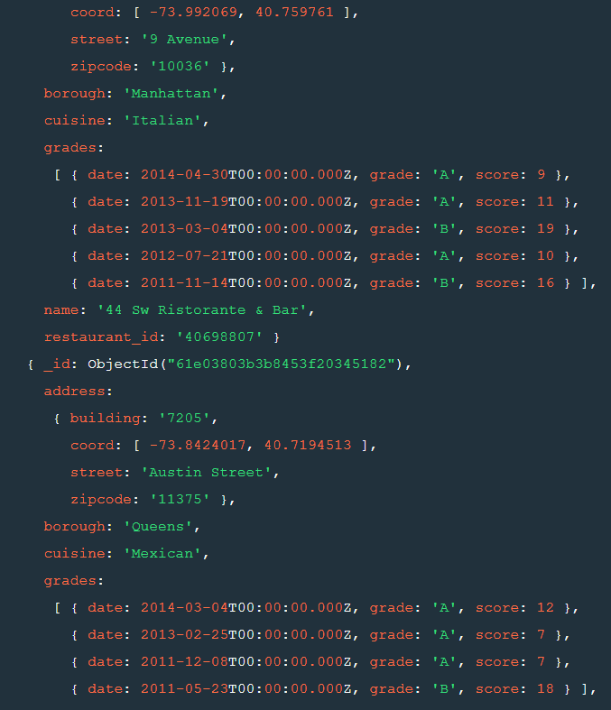

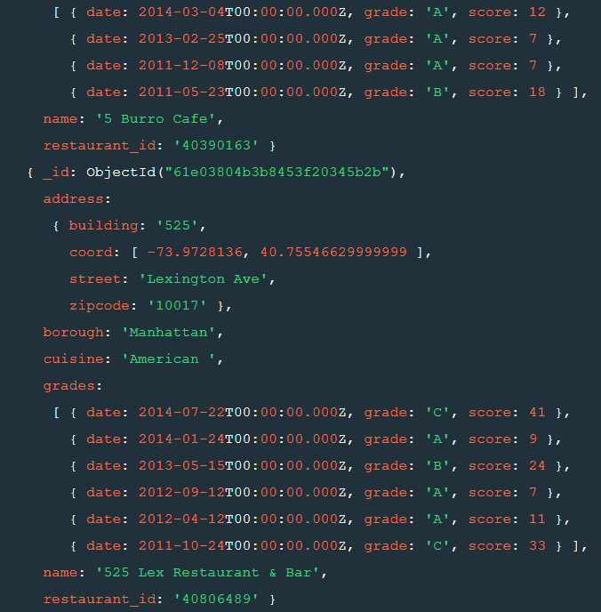

26. Write a MongoDB query to arrange the name of the restaurants in descending along with all the columns.



**id ("61e03803b3b8453f20344f54"),**

**address:**

**{ building: '6946',**

**coord: [ -73.8811834, 40.7017759 ],**

**street: 'Myrtle Avenue',**

**zipcode: '11385' },**

**borough: 'Queens',**

**cuisine: 'German',**

**grades:**

**[ { date: 2014-09-24T00:00:00.000Z, grade: 'A', score: 11 },**

**{ date: 2014-04-17T00:00:00.000Z, grade: 'A', score: 7 },**

**{ date: 2013-03-12T00:00:00.000Z, grade: 'A', score: 13 },**

**{ date: 2012-10-02T00:00:00.000Z, grade: 'A', score: 9 },**

**{ date: 2012-05-09T00:00:00.000Z, grade: 'A', score: 13 },**

**{ date: 2011-12-28T00:00:00.000Z, grade: 'B', score: 24 } ],**

**name: 'Zum Stammtisch',**

**restaurant_id: '40367377' }**

**{ _id: ObjectId("61e03804b3b8453f20345a8e"),**

**address:**

**{ building: '107109',**

**coord: [ -73.9744668, 40.731155 ],**

**street: 'Avenue C',**

**zipcode: '10009' },**

**borough: 'Manhattan',**

**cuisine: 'German',**

**grades:**

**[ { date: 2014-03-04T00:00:00.000Z, grade: 'A', score: 7 },**

**{ date: 2013-08-21T00:00:00.000Z, grade: 'A', score: 13 },**

**{ date: 2013-02-27T00:00:00.000Z, grade: 'A', score: 11 },**

**{ date: 2012-06-05T00:00:00.000Z, grade: 'A', score: 12 },**

**{ date: 2011-12-20T00:00:00.000Z, grade: 'A', score: 9 },**

**{ date: 2011-07-15T00:00:00.000Z, grade: 'A', score: 6 } ],**

**name: 'Zum Schneider',**

**restaurant_id: '40763382' }**

**{ _id: ObjectId("61e03804b3b8453f20345cc8"),**

**address:**

**{ building: '2905',**

**coord: [ -73.91337299999999, 40.775064 ],**

**street: '23 Avenue',**

**zipcode: '11105' },**

**borough: 'Queens',**

**cuisine: 'Greek',**

**grades:**

**[ { date: 2014-09-29T00:00:00.000Z, grade: 'A', score: 7 },**

**{ date: 2014-04-18T00:00:00.000Z, grade: 'A', score: 13 },**

**{ date: 2013-03-19T00:00:00.000Z, grade: 'A', score: 12 },**

**{ date: 2012-10-03T00:00:00.000Z, grade: 'B', score: 20 },**

**{ date: 2012-05-07T00:00:00.000Z, grade: 'A', score: 12 } ],**

**name: 'Zorba\'S',**

**restaurant_id: '40877247' }**

**{ _id: ObjectId("61e03804b3b8453f20345b10"),**

**address:**

**{ building: '305',**

**coord: [ -73.94830499999999, 40.781662 ],**

**street: 'East 92 Street',**

**zipcode: '10128' },**

**borough: 'Manhattan',**

**cuisine: 'Brazilian',**

**grades:**

**[ { date: 2015-01-09T00:00:00.000Z, grade: 'A', score: 10 },**

**{ date: 2014-07-16T00:00:00.000Z, grade: 'A', score: 7 },**

**{ date: 2013-04-26T00:00:00.000Z, grade: 'A', score: 10 },**

**{ date: 2012-04-21T00:00:00.000Z, grade: 'A', score: 12 } ],**

**name: 'Zebu Grill',**

**restaurant_id: '40800325' }**

**{ _id: ObjectId("61e03804b3b8453f203452cb"),**

**address:**

**{ building: '29',**

**coord: [ -73.86119219999999, 40.8338023 ],**

**street: 'Hugh Grant Circle',**

**zipcode: '10462' },**

**borough: 'Bronx',**

**cuisine: 'Bakery',**

**grades:**

**[ { date: 2014-08-27T00:00:00.000Z, grade: 'A', score: 9 },**

**{ date: 2013-09-10T00:00:00.000Z, grade: 'A', score: 0 },**

**{ date: 2013-05-07T00:00:00.000Z, grade: 'C', score: 2 },**

**{ date: 2013-03-23T00:00:00.000Z, grade: 'P', score: 13 },**

**{ date: 2012-10-24T00:00:00.000Z, grade: 'A', score: 12 },**

**{ date: 2011-11-01T00:00:00.000Z, grade: 'A', score: 13 } ],**

**name: 'Zaro\'S Bread Basket',**

**restaurant_id: '40397863' }**

**{ _id: ObjectId("61e03804b3b8453f20345446"),**

**address:**

**{ building: '1',**

**coord: [ -76.878256, 40.26205 ],**

**street: 'Pennsylvania Station (Amtrack)',**

**zipcode: '10001' },**

**borough: 'Manhattan',**

**cuisine: 'Bakery',**

**grades:**

**[ { date: 2014-02-07T00:00:00.000Z, grade: 'A', score: 9 },**

**{ date: 2013-02-11T00:00:00.000Z, grade: 'A', score: 5 },**

**{ date: 2012-09-18T00:00:00.000Z, grade: 'A', score: 11 },**

**{ date: 2012-04-05T00:00:00.000Z, grade: 'A', score: 5 },**

**{ date: 2011-11-17T00:00:00.000Z, grade: 'A', score: 2 },**

**{ date: 2011-07-05T00:00:00.000Z, grade: 'A', score: 4 } ],**

**name: 'Zaro\'S Bread Basket',**

**restaurant_id: '40510389' }**

**{ _id: ObjectId("61e03804b3b8453f20345470"),**

**address:**

**{ building: '89',**

**coord: [ -73.97729919999999, 40.7524958 ],**

**street: 'East 42 Street',**

**zipcode: '10017' },**

**borough: 'Manhattan',**

**cuisine: 'Bakery',**

**grades:**

**[ { date: 2014-12-23T00:00:00.000Z, grade: 'A', score: 12 },**

**{ date: 2014-01-13T00:00:00.000Z, grade: 'A', score: 4 },**

**{ date: 2013-01-23T00:00:00.000Z, grade: 'A', score: 2 },**

**{ date: 2012-08-20T00:00:00.000Z, grade: 'A', score: 13 },**

**{ date: 2012-03-30T00:00:00.000Z, grade: 'A', score: 9 } ],**

**name: 'Zaro\'S Bread Basket',**

**restaurant_id: '40512617' }**

**{ _id: ObjectId("61e03804b3b8453f20345690"),**

**address:**

**{ building: '89',**

**coord: [ -73.97729919999999, 40.7524958 ],**

**street: 'East 42 Street',**

**zipcode: '10017' },**

**borough: 'Manhattan',**

**cuisine: 'Bakery',**

**grades:**

**[ { date: 2014-12-11T00:00:00.000Z, grade: 'A', score: 8 },**

**{ date: 2014-07-17T00:00:00.000Z, grade: 'A', score: 13 },**

**{ date: 2013-06-26T00:00:00.000Z, grade: 'A', score: 7 },**

**{ date: 2013-01-29T00:00:00.000Z, grade: 'A', score: 5 },**

**{ date: 2012-07-16T00:00:00.000Z, grade: 'A', score: 13 } ],**

**name: 'Zaro\'S Bread Basket',**

**restaurant_id: '40586000' }**

**{ _id: ObjectId("61e03804b3b8453f20345a41"),**

**address:**

**{ building: '2',**

**coord: [ -73.992255, 40.749712 ],**

**street: 'Penn Plaza',**

**zipcode: '10121' },**

**borough: 'Manhattan',**

**cuisine: 'Bakery',**

**grades:**

**[ { date: 2014-02-18T00:00:00.000Z, grade: 'A', score: 7 },**

**{ date: 2013-01-22T00:00:00.000Z, grade: 'A', score: 3 },**

**{ date: 2012-03-21T00:00:00.000Z, grade: 'A', score: 10 },**

**{ date: 2011-11-09T00:00:00.000Z, grade: 'A', score: 12 },**

**{ date: 2011-07-25T00:00:00.000Z, grade: 'B', score: 18 } ],**

**name: 'Zaro\'S Bread Basket',**

**restaurant_id: '40750766' }**

**{ _id: ObjectId("61e03804b3b8453f20345407"),**

**address:**

**{ building: '89',**

**coord: [ -73.97729919999999, 40.7524958 ],**

**street: 'East 42 Street',**

**zipcode: '10017' },**

**borough: 'Manhattan',**

**cuisine: 'American ',**

**grades:**

**[ { date: 2014-09-29T00:00:00.000Z, grade: 'A', score: 2 },**

**{ date: 2013-09-11T00:00:00.000Z, grade: 'A', score: 13 },**

**{ date: 2012-09-14T00:00:00.000Z, grade: 'A', score: 10 } ],**

**name: 'Zaro\'S Bakery',**

**restaurant_id: '40423705' }**

**{ _id: ObjectId("61e03804b3b8453f20345891"),**

**address:**

**{ building: '370',**

**coord: [ -73.9768121, 40.7507385 ],**

**street: 'Lexington Avenue',**

**zipcode: '10017' },**

**borough: 'Manhattan',**

**cuisine: 'Bakery',**

**grades:**

**[ { date: 2014-09-18T00:00:00.000Z, grade: 'A', score: 9 },**

**{ date: 2013-09-09T00:00:00.000Z, grade: 'A', score: 12 },**

**{ date: 2013-04-08T00:00:00.000Z, grade: 'B', score: 14 },**

**{ date: 2012-10-15T00:00:00.000Z, grade: 'A', score: 12 },**

**{ date: 2012-05-24T00:00:00.000Z, grade: 'A', score: 8 },**

**{ date: 2011-10-31T00:00:00.000Z, grade: 'B', score: 25 } ],**

**name: 'Zaro\'S Bakery',**

**restaurant_id: '40686674' }**

**{ _id: ObjectId("61e03803b3b8453f20344fe1"),**

**address:**

**{ building: '500',**

**coord: [ -73.9828058, 40.7150766 ],**

**street: 'Grand Street',**

**zipcode: '10002' },**

**borough: 'Manhattan',**

**cuisine: 'American ',**

**grades:**

**[ { date: 2014-03-20T00:00:00.000Z, grade: 'A', score: 2 },**

**{ date: 2013-03-13T00:00:00.000Z, grade: 'A', score: 8 },**

**{ date: 2012-10-19T00:00:00.000Z, grade: 'A', score: 7 },**

**{ date: 2012-05-25T00:00:00.000Z, grade: 'A', score: 9 },**

**{ date: 2011-06-08T00:00:00.000Z, grade: 'A', score: 8 } ],**

**name: 'Zafi\'S Luncheonette',**

**restaurant_id: '40371718' }**

**{ _id: ObjectId("61e03804b3b8453f20345cbb"),**

**address:**

**{ building: '301',**

**coord: [ -73.9465592, 40.8165415 ],**

**street: 'West 135 Street',**

**zipcode: '10030' },**

**borough: 'Manhattan',**

**cuisine: 'Caribbean',**

**grades:**

**[ { date: 2014-01-08T00:00:00.000Z, grade: 'A', score: 13 },**

**{ date: 2013-07-12T00:00:00.000Z, grade: 'A', score: 12 },**

**{ date: 2013-01-30T00:00:00.000Z, grade: 'A', score: 7 },**

**{ date: 2012-12-06T00:00:00.000Z, grade: 'C', score: 11 },**

**{ date: 2012-02-28T00:00:00.000Z, grade: 'B', score: 16 } ],**

**name: 'Yvonne Yvonne Restaurant',**

**restaurant_id: '40875849' }**

**{ _id: ObjectId("61e03804b3b8453f203457d7"),**

**address:**

**{ building: '1292',**

**coord: [ -73.9563202, 40.7846507 ],**

**street: 'Madison Avenue',**

**zipcode: '10128' },**

**borough: 'Manhattan',**

**cuisine: 'American ',**

**grades:**

**[ { date: 2015-01-05T00:00:00.000Z, grade: 'A', score: 7 },**

**{ date: 2014-08-08T00:00:00.000Z, grade: 'A', score: 7 },**

**{ date: 2013-12-17T00:00:00.000Z, grade: 'A', score: 10 },**

**{ date: 2013-07-10T00:00:00.000Z, grade: 'A', score: 6 },**

**{ date: 2013-01-08T00:00:00.000Z, grade: 'C', score: 41 } ],**

**name: 'Yura & Company On Madison',**

**restaurant_id: '40646987' }**

**{ _id: ObjectId("61e03804b3b8453f20345a8c"),**

**address:**

**{ building: '9021',**

**coord: [ -73.87785749999999, 40.760312 ],**

**street: '31 Avenue',**

**zipcode: '11369' },**

**borough: 'Queens',**

**cuisine: 'Chinese',**

**grades:**

**[ { date: 2014-12-10T00:00:00.000Z, grade: 'A', score: 13 },**

**{ date: 2014-06-12T00:00:00.000Z, grade: 'A', score: 12 },**

**{ date: 2013-11-12T00:00:00.000Z, grade: 'A', score: 9 },**

**{ date: 2013-04-10T00:00:00.000Z, grade: 'A', score: 2 },**

**{ date: 2012-10-17T00:00:00.000Z, grade: 'B', score: 22 },**

**{ date: 2012-05-23T00:00:00.000Z, grade: 'A', score: 8 },**

**{ date: 2011-12-22T00:00:00.000Z, grade: 'P', score: 6 } ],**

**name: 'Yummy Kitchen',**

**restaurant_id: '40763160' }**

**{ _id: ObjectId("61e03804b3b8453f203454ce"),**

**address:**

**{ building: '518',**

**coord: [ -74.02590599999999, 40.6209702 ],**

**street: '86 Street',**

**zipcode: '11209' },**

**borough: 'Brooklyn',**

**cuisine: 'Bakery',**

**grades:**

**[ { date: 2014-05-01T00:00:00.000Z, grade: 'A', score: 3 },**

**{ date: 2013-04-25T00:00:00.000Z, grade: 'A', score: 12 },**

**{ date: 2012-11-19T00:00:00.000Z, grade: 'A', score: 5 },**

**{ date: 2011-11-04T00:00:00.000Z, grade: 'A', score: 13 } ],**

**name: 'Your Bakery',**

**restaurant_id: '40529415' }**

**{ _id: ObjectId("61e03804b3b8453f20345530"),**

**address:**

**{ building: '137',**

**coord: [ -73.9901259, 40.7231435 ],**

**street: 'East Houston Street',**

**zipcode: '10002' },**

**borough: 'Manhattan',**

**cuisine: 'Eastern European',**

**grades:**

**[ { date: 2014-06-23T00:00:00.000Z, grade: 'A', score: 11 },**

**{ date: 2013-06-03T00:00:00.000Z, grade: 'A', score: 12 },**

**{ date: 2012-06-25T00:00:00.000Z, grade: 'A', score: 9 },**

**{ date: 2012-01-31T00:00:00.000Z, grade: 'A', score: 10 },**

**{ date: 2011-08-30T00:00:00.000Z, grade: 'A', score: 10 } ],**

**name: 'Yonah Shimmels Knishes',**

**restaurant_id: '40544576' }**

**{ _id: ObjectId("61e03804b3b8453f203456d9"),**

**address:**

**{ building: '292',**

**coord: [ -73.9218923, 40.8169858 ],**

**street: 'East 149 Street',**

**zipcode: '10451' },**

**borough: 'Bronx',**

**cuisine: 'Pizza/Italian',**

**grades:**

**[ { date: 2014-10-06T00:00:00.000Z, grade: 'A', score: 7 },**

**{ date: 2014-05-20T00:00:00.000Z, grade: 'A', score: 13 },**

**{ date: 2013-03-25T00:00:00.000Z, grade: 'A', score: 12 },**

**{ date: 2012-09-20T00:00:00.000Z, grade: 'A', score: 11 } ],**

**name: 'Yolanda Pizzeria Restaurant',**

**restaurant_id: '40594879' }**

**{ _id: ObjectId("61e03803b3b8453f2034513c"),**

**address:**

**{ building: '1290',**

**coord: [ -73.9788903, 40.7605367 ],**

**street: 'Avenue Of Americas',**

**zipcode: '10119' },**

**borough: 'Manhattan',**

**cuisine: 'Chinese',**

**grades:**

**[ { date: 2014-09-23T00:00:00.000Z, grade: 'A', score: 10 },**

**{ date: 2013-12-11T00:00:00.000Z, grade: 'A', score: 12 },**

**{ date: 2013-04-09T00:00:00.000Z, grade: 'B', score: 26 },**

**{ date: 2012-10-04T00:00:00.000Z, grade: 'B', score: 23 },**

**{ date: 2012-05-07T00:00:00.000Z, grade: 'A', score: 13 },**

**{ date: 2011-12-20T00:00:00.000Z, grade: 'B', score: 22 } ],**

**name: 'Yip\'S',**

**restaurant_id: '40388209' }**

**{ _id: ObjectId("61e03803b3b8453f203451ed"),**

**address:**

**{ building: '404',**

**coord: [ -73.97635439999999, 40.6438997 ],**

**street: 'Church Avenue',**

**zipcode: '11218' },**

**borough: 'Brooklyn',**

**cuisine: 'Chinese',**

**grades:**

**[ { date: 2014-10-29T00:00:00.000Z, grade: 'A', score: 13 },**

**{ date: 2014-03-24T00:00:00.000Z, grade: 'A', score: 11 },**

**{ date: 2013-10-25T00:00:00.000Z, grade: 'C', score: 3 },**

**{ date: 2012-10-01T00:00:00.000Z, grade: 'A', score: 9 },**

**{ date: 2012-05-09T00:00:00.000Z, grade: 'C', score: 2 } ],**

**name: 'Yen Yen Restaurant',**

**restaurant_id: '40393181' }**

27. Write a MongoDB query to arranged the name of the cuisine in ascending order and for that same cuisine borough should be in descending order.



**{ _id: ObjectId("61e03804b3b8453f20345580"),**

**address:**

**{ building: '1345',**

**coord: [ -73.959249, 40.768076 ],**

**street: '2 Avenue',**

**zipcode: '10021' },**

**borough: 'Manhattan',**

**cuisine: 'Afghan',**

**grades:**

**[ { date: 2014-10-07T00:00:00.000Z, grade: 'A', score: 9 },**

**{ date: 2013-10-23T00:00:00.000Z, grade: 'A', score: 8 },**

**{ date: 2012-10-26T00:00:00.000Z, grade: 'A', score: 13 },**

**{ date: 2012-04-26T00:00:00.000Z, grade: 'A', score: 7 },**

**{ date: 2012-01-12T00:00:00.000Z, grade: 'P', score: 10 } ],**

**name: 'Afghan Kebab House',**

**restaurant_id: '40552806' }**

**{ _id: ObjectId("61e03804b3b8453f203456ab"),**

**address:**

**{ building: '34',**

**coord: [ -73.9883612, 40.7286391 ],**

**street: 'St Marks Place',**

**zipcode: '10003' },**

**borough: 'Manhattan',**

**cuisine: 'Afghan',**

**grades:**

**[ { date: 2014-02-20T00:00:00.000Z, grade: 'A', score: 12 },**

**{ date: 2013-08-06T00:00:00.000Z, grade: 'B', score: 17 },**

**{ date: 2013-01-31T00:00:00.000Z, grade: 'A', score: 13 },**

**{ date: 2012-05-24T00:00:00.000Z, grade: 'A', score: 10 },**

**{ date: 2011-12-13T00:00:00.000Z, grade: 'A', score: 10 },**

**{ date: 2011-08-25T00:00:00.000Z, grade: 'A', score: 10 } ],**

**name: 'Khyber Pass',**

**restaurant_id: '40589545' }**

**{ _id: ObjectId("61e03804b3b8453f20345764"),**

**address:**

**{ building: '764',**

**coord: [ -73.9880435, 40.7641423 ],**

**street: '9 Avenue',**

**zipcode: '10019' },**

**borough: 'Manhattan',**

**cuisine: 'Afghan',**

**grades:**

**[ { date: 2014-12-30T00:00:00.000Z, grade: 'A', score: 12 },**

**{ date: 2013-10-10T00:00:00.000Z, grade: 'B', score: 19 },**

**{ date: 2013-02-25T00:00:00.000Z, grade: 'A', score: 13 },**

**{ date: 2012-08-09T00:00:00.000Z, grade: 'C', score: 2 },**

**{ date: 2012-02-16T00:00:00.000Z, grade: 'A', score: 9 } ],**

**name: 'Afghan Kebab House #1',**

**restaurant_id: '40616799' }**

**{ _id: ObjectId("61e03804b3b8453f20345c87"),**

**address:**

**{ building: '787',**

**coord: [ -73.9880886, 40.7651331 ],**

**street: '9 Avenue',**

**zipcode: '10019' },**

**borough: 'Manhattan',**

**cuisine: 'Afghan',**

**grades:**

**[ { date: 2014-07-22T00:00:00.000Z, grade: 'A', score: 3 },**

**{ date: 2013-07-08T00:00:00.000Z, grade: 'A', score: 2 },**

**{ date: 2013-02-05T00:00:00.000Z, grade: 'A', score: 2 },**

**{ date: 2011-11-28T00:00:00.000Z, grade: 'A', score: 13 } ],**

**name: 'Ariana Kebab House',**

**restaurant_id: '40868400' }**

**{ _id: ObjectId("61e03804b3b8453f20345afc"),**

**address:**

**{ building: '14612',**

**coord: [ -73.8057078, 40.6948408 ],**

**street: 'Liberty Avenue',**

**zipcode: '11435' },**

**borough: 'Queens',**

**cuisine: 'African',**

**grades:**

**[ { date: 2014-04-16T00:00:00.000Z, grade: 'A', score: 4 },**

**{ date: 2013-09-16T00:00:00.000Z, grade: 'A', score: 2 },**

**{ date: 2012-08-23T00:00:00.000Z, grade: 'A', score: 13 },**

**{ date: 2012-02-21T00:00:00.000Z, grade: 'A', score: 11 },**

**{ date: 2011-06-30T00:00:00.000Z, grade: 'B', score: 19 } ],**

**name: 'Africana Restaurant',**

**restaurant_id: '40798504' }**

**{ _id: ObjectId("61e03804b3b8453f20345886"),**

**address:**

**{ building: '195',**

**coord: [ -73.9717845, 40.6897199 ],**

**street: 'Dekalb Avenue',**

**zipcode: '11205' },**

**borough: 'Brooklyn',**

**cuisine: 'African',**

**grades:**

**[ { date: 2014-08-18T00:00:00.000Z, grade: 'A', score: 7 },**

**{ date: 2014-01-13T00:00:00.000Z, grade: 'B', score: 19 },**

**{ date: 2012-12-19T00:00:00.000Z, grade: 'A', score: 7 },**

**{ date: 2012-08-01T00:00:00.000Z, grade: 'A', score: 10 },**

**{ date: 2012-03-12T00:00:00.000Z, grade: 'A', score: 12 },**

**{ date: 2011-11-01T00:00:00.000Z, grade: 'A', score: 10 } ],**

**name: 'Madiba',**

**restaurant_id: '40684161' }**

**{ _id: ObjectId("61e03803b3b8453f20344f6d"),**

**address:**

**{ building: '2300',**

**coord: [ -73.8786113, 40.8502883 ],**

**street: 'Southern Boulevard',**

**zipcode: '10460' },**

**borough: 'Bronx',**

**cuisine: 'African',**

**grades:**

**[ { date: 2014-05-21T00:00:00.000Z, grade: 'A', score: 8 },**

**{ date: 2013-06-01T00:00:00.000Z, grade: 'A', score: 6 },**

**{ date: 2012-06-12T00:00:00.000Z, grade: 'A', score: 0 },**

**{ date: 2011-06-08T00:00:00.000Z, grade: 'A', score: 0 } ],**

**name: 'African Terrace',**

**restaurant_id: '40368021' }**

**{ _id: ObjectId("61e03804b3b8453f20345bb4"),**

**address:**

**{ building: '2364',**

**coord: [ -73.9025083, 40.8603246 ],**

**street: 'Jerome Avenue',**

**zipcode: '10468' },**

**borough: 'Bronx',**

**cuisine: 'African',**

**grades:**

**[ { date: 2014-04-22T00:00:00.000Z, grade: 'A', score: 12 },**

**{ date: 2013-10-22T00:00:00.000Z, grade: 'A', score: 9 },**

**{ date: 2012-09-18T00:00:00.000Z, grade: 'A', score: 11 },**

**{ date: 2011-10-04T00:00:00.000Z, grade: 'A', score: 13 },**

**{ date: 2011-05-26T00:00:00.000Z, grade: 'A', score: 11 } ],**

**name: 'Ebe Ye Yie African Restaurant',**

**restaurant_id: '40832718' }**

**{ _id: ObjectId("61e03803b3b8453f20344ee0"),**

**address:**

**{ building: '37',**

**coord: [ -74.138263, 40.546681 ],**

**street: 'Mansion Ave',**

**zipcode: '10308' },**

**borough: 'Staten Island',**

**cuisine: 'American ',**

**grades:**

**[ { date: 2014-04-22T00:00:00.000Z, grade: 'A', score: 10 },**

**{ date: 2013-09-25T00:00:00.000Z, grade: 'A', score: 4 },**

**{ date: 2012-06-09T00:00:00.000Z, grade: 'A', score: 8 } ],**

**name: 'Great Kills Yacht Club',**

**restaurant_id: '40364610' }**

**{ _id: ObjectId("61e03803b3b8453f20344eed"),**

**address:**

**{ building: '390',**

**coord: [ -74.07444319999999, 40.6096914 ],**

**street: 'Hylan Boulevard',**

**zipcode: '10305' },**

**borough: 'Staten Island',**

**cuisine: 'American ',**

**grades:**

**[ { date: 2014-06-21T00:00:00.000Z, grade: 'A', score: 9 },**

**{ date: 2013-06-15T00:00:00.000Z, grade: 'A', score: 13 },**

**{ date: 2012-08-30T00:00:00.000Z, grade: 'A', score: 10 },**

**{ date: 2011-10-07T00:00:00.000Z, grade: 'B', score: 20 } ],**

**name: 'Labetti\'S Post # 2159',**

**restaurant_id: '40365022' }**

**{ _id: ObjectId("61e03803b3b8453f20344ef1"),**

**address:**

**{ building: '6736',**

**coord: [ -74.2274942, 40.5071996 ],**

**street: 'Hylan Boulevard',**

**zipcode: '10309' },**

**borough: 'Staten Island',**

**cuisine: 'American ',**

**grades:**

**[ { date: 2014-08-13T00:00:00.000Z, grade: 'A', score: 3 },**

**{ date: 2013-08-20T00:00:00.000Z, grade: 'B', score: 19 },**

**{ date: 2012-06-18T00:00:00.000Z, grade: 'A', score: 6 } ],**

**name: 'South Shore Swimming Club',**

**restaurant_id: '40365120' }**

**{ _id: ObjectId("61e03803b3b8453f20344f0c"),**

**address:**

**{ building: '3823',**

**coord: [ -74.16536339999999, 40.5450793 ],**

**street: 'Richmond Avenue',**

**zipcode: '10312' },**

**borough: 'Staten Island',**

**cuisine: 'American ',**

**grades:**

**[ { date: 2014-07-15T00:00:00.000Z, grade: 'B', score: 20 },**

**{ date: 2013-04-01T00:00:00.000Z, grade: 'A', score: 12 },**

**{ date: 2012-03-12T00:00:00.000Z, grade: 'A', score: 11 } ],**

**name: 'Joyce\'S Tavern',**

**restaurant_id: '40365692' }**

**{ _id: ObjectId("61e03803b3b8453f20344f36"),**

**address:**

**{ building: '697',**

**coord: [ -74.11223799999999, 40.629819 ],**

**street: 'Forest Avenue',**

**zipcode: '10310' },**

**borough: 'Staten Island',**

**cuisine: 'American ',**

**grades:**

**[ { date: 2014-07-17T00:00:00.000Z, grade: 'B', score: 25 },**

**{ date: 2013-10-03T00:00:00.000Z, grade: 'B', score: 22 },**

**{ date: 2013-02-13T00:00:00.000Z, grade: 'A', score: 12 },**

**{ date: 2012-06-11T00:00:00.000Z, grade: 'A', score: 13 },**

**{ date: 2012-01-05T00:00:00.000Z, grade: 'A', score: 13 } ],**

**name: 'Li Greci\'S Staaten Restaurant',**

**restaurant_id: '40366711' }**

**{ _id: ObjectId("61e03803b3b8453f20344f3e"),**

**address:**

**{ building: '135',**

**coord: [ -74.10465599999999, 40.58834 ],**

**street: 'Flagg Place',**

**zipcode: '10304' },**

**borough: 'Staten Island',**

**cuisine: 'American ',**

**grades:**

**[ { date: 2014-07-10T00:00:00.000Z, grade: 'A', score: 11 },**

**{ date: 2013-05-22T00:00:00.000Z, grade: 'A', score: 13 },**

**{ date: 2012-11-29T00:00:00.000Z, grade: 'A', score: 13 },**

**{ date: 2012-04-13T00:00:00.000Z, grade: 'B', score: 23 },**

**{ date: 2011-08-13T00:00:00.000Z, grade: 'A', score: 11 } ],**

**name: 'Richmond County Country Club',**

**restaurant_id: '40366928' }**

**{ _id: ObjectId("61e03803b3b8453f20344f57"),**

**address:**

**{ building: '17',**

**coord: [ -74.1350211, 40.6369042 ],**

**street: 'Harrison Avenue',**

**zipcode: '10302' },**

**borough: 'Staten Island',**

**cuisine: 'American ',**

**grades:**

**[ { date: 2014-07-22T00:00:00.000Z, grade: 'B', score: 15 },**

**{ date: 2013-10-23T00:00:00.000Z, grade: 'B', score: 16 },**

**{ date: 2013-04-16T00:00:00.000Z, grade: 'B', score: 17 },**

**{ date: 2012-03-31T00:00:00.000Z, grade: 'A', score: 13 } ],**

**name: 'Buddy\'S Wonder Bar',**

**restaurant_id: '40367442' }**

**{ _id: ObjectId("61e03803b3b8453f20344f77"),**

**address:**

**{ building: '2001',**

**coord: [ -74.099018, 40.58116500000001 ],**

**street: 'Hylan Boulevard',**

**zipcode: '10306' },**

**borough: 'Staten Island',**

**cuisine: 'American ',**

**grades:**

**[ { date: 2014-10-06T00:00:00.000Z, grade: 'A', score: 12 },**

**{ date: 2014-03-20T00:00:00.000Z, grade: 'A', score: 8 },**

**{ date: 2013-09-26T00:00:00.000Z, grade: 'A', score: 10 },**

**{ date: 2013-04-01T00:00:00.000Z, grade: 'A', score: 13 },**

**{ date: 2012-03-05T00:00:00.000Z, grade: 'A', score: 9 } ],**

**name: 'Colonnade Diner',**

**restaurant_id: '40368291' }**

**{ _id: ObjectId("61e03803b3b8453f20344f94"),**

**address:**

**{ building: '372',**

**coord: [ -74.1018239, 40.630788 ],**

**street: 'Forest Avenue',**

**zipcode: '10301' },**

**borough: 'Staten Island',**

**cuisine: 'American ',**

**grades:**

**[ { date: 2014-03-08T00:00:00.000Z, grade: 'A', score: 10 },**

**{ date: 2013-09-17T00:00:00.000Z, grade: 'A', score: 2 },**

**{ date: 2013-02-14T00:00:00.000Z, grade: 'A', score: 11 },**

**{ date: 2012-07-14T00:00:00.000Z, grade: 'A', score: 13 },**

**{ date: 2011-12-14T00:00:00.000Z, grade: 'A', score: 13 },**

**{ date: 2011-07-11T00:00:00.000Z, grade: 'A', score: 9 } ],**

**name: 'Jody\'S Club',**

**restaurant_id: '40369158' }**

**{ _id: ObjectId("61e03803b3b8453f20344fd2"),**

**address:**

**{ building: '1745',**

**coord: [ -74.146976, 40.625178 ],**

**street: 'Forest Avenue',**

**zipcode: '10303' },**

**borough: 'Staten Island',**

**cuisine: 'American ',**

**grades:**

**[ { date: 2014-11-15T00:00:00.000Z, grade: 'A', score: 8 },**

**{ date: 2014-06-24T00:00:00.000Z, grade: 'A', score: 10 },**

**{ date: 2014-01-08T00:00:00.000Z, grade: 'A', score: 12 },**

**{ date: 2012-12-07T00:00:00.000Z, grade: 'A', score: 12 },**

**{ date: 2012-06-23T00:00:00.000Z, grade: 'A', score: 13 },**

**{ date: 2012-01-24T00:00:00.000Z, grade: 'A', score: 9 } ],**

**name: 'Perkins Family Restaurant & Bakery',**

**restaurant_id: '40370910' }**

**{ _id: ObjectId("61e03803b3b8453f20344fe3"),**

**address:**

**{ building: '2055',**

**coord: [ -74.1321, 40.61266000000001 ],**

**street: 'Victory Boulevard',**

**zipcode: '10314' },**

**borough: 'Staten Island',**

**cuisine: 'American ',**

**grades:**

**[ { date: 2014-11-06T00:00:00.000Z, grade: 'B', score: 25 },**

**{ date: 2014-05-06T00:00:00.000Z, grade: 'B', score: 20 },**

**{ date: 2013-01-26T00:00:00.000Z, grade: 'A', score: 13 },**

**{ date: 2011-12-17T00:00:00.000Z, grade: 'A', score: 7 } ],**

**name: 'Schaffer\'S Tavern',**

**restaurant_id: '40371771' }**

**{ _id: ObjectId("61e03803b3b8453f20344fe8"),**

**address:**

**{ building: '275',**

**coord: [ -74.1235473, 40.6215341 ],**

**street: 'Martling Ave',**

**zipcode: '10314' },**

**borough: 'Staten Island',**

**cuisine: 'American ',**

**grades:**

**[ { date: 2014-04-09T00:00:00.000Z, grade: 'A', score: 5 },**

**{ date: 2013-01-16T00:00:00.000Z, grade: 'A', score: 13 },**

**{ date: 2012-01-06T00:00:00.000Z, grade: 'A', score: 11 } ],**

**name: 'Exclusive Catering',**

**restaurant_id: '40372016' }**

28. Write a MongoDB query to know whether all the addresses contains the street or not.



**{ _id: ObjectId("61e03803b3b8453f20344e95"),**

**address:**

**{ building: '1007',**

**coord: [ -73.856077, 40.848447 ],**

**street: 'Morris Park Ave',**

**zipcode: '10462' },**

**borough: 'Bronx',**

**cuisine: 'Bakery',**

**grades:**

**[ { date: 2014-03-03T00:00:00.000Z, grade: 'A', score: 2 },**

**{ date: 2013-09-11T00:00:00.000Z, grade: 'A', score: 6 },**

**{ date: 2013-01-24T00:00:00.000Z, grade: 'A', score: 10 },**

**{ date: 2011-11-23T00:00:00.000Z, grade: 'A', score: 9 },**

**{ date: 2011-03-10T00:00:00.000Z, grade: 'B', score: 14 } ],**

**name: 'Morris Park Bake Shop',**

**restaurant_id: '30075445' }**

**{ _id: ObjectId("61e03803b3b8453f20344e96"),**

**address:**

**{ building: '469',**

**coord: [ -73.961704, 40.662942 ],**

**street: 'Flatbush Avenue',**

**zipcode: '11225' },**

**borough: 'Brooklyn',**

**cuisine: 'Hamburgers',**

**grades:**

**[ { date: 2014-12-30T00:00:00.000Z, grade: 'A', score: 8 },**

**{ date: 2014-07-01T00:00:00.000Z, grade: 'B', score: 23 },**

**{ date: 2013-04-30T00:00:00.000Z, grade: 'A', score: 12 },**

**{ date: 2012-05-08T00:00:00.000Z, grade: 'A', score: 12 } ],**

**name: 'Wendy\'S',**

**restaurant_id: '30112340' }**

**{ _id: ObjectId("61e03803b3b8453f20344e97"),**

**address:**

**{ building: '351',**

**coord: [ -73.98513559999999, 40.7676919 ],**

**street: 'West 57 Street',**

**zipcode: '10019' },**

**borough: 'Manhattan',**

**cuisine: 'Irish',**

**grades:**

**[ { date: 2014-09-06T00:00:00.000Z, grade: 'A', score: 2 },**

**{ date: 2013-07-22T00:00:00.000Z, grade: 'A', score: 11 },**

**{ date: 2012-07-31T00:00:00.000Z, grade: 'A', score: 12 },**

**{ date: 2011-12-29T00:00:00.000Z, grade: 'A', score: 12 } ],**

**name: 'Dj Reynolds Pub And Restaurant',**

**restaurant_id: '30191841' }**

**{ _id: ObjectId("61e03803b3b8453f20344e98"),**

**address:**

**{ building: '2780',**

**coord: [ -73.98241999999999, 40.579505 ],**

**street: 'Stillwell Avenue',**

**zipcode: '11224' },**

**borough: 'Brooklyn',**

**cuisine: 'American ',**

**grades:**

**[ { date: 2014-06-10T00:00:00.000Z, grade: 'A', score: 5 },**

**{ date: 2013-06-05T00:00:00.000Z, grade: 'A', score: 7 },**

**{ date: 2012-04-13T00:00:00.000Z, grade: 'A', score: 12 },**

**{ date: 2011-10-12T00:00:00.000Z, grade: 'A', score: 12 } ],**

**name: 'Riviera Caterer',**

**restaurant_id: '40356018' }**

**{ _id: ObjectId("61e03803b3b8453f20344e99"),**

**address:**

**{ building: '97-22',**

**coord: [ -73.8601152, 40.7311739 ],**

**street: '63 Road',**

**zipcode: '11374' },**

**borough: 'Queens',**

**cuisine: 'Jewish/Kosher',**

**grades:**

**[ { date: 2014-11-24T00:00:00.000Z, grade: 'Z', score: 20 },**

**{ date: 2013-01-17T00:00:00.000Z, grade: 'A', score: 13 },**

**{ date: 2012-08-02T00:00:00.000Z, grade: 'A', score: 13 },**

**{ date: 2011-12-15T00:00:00.000Z, grade: 'B', score: 25 } ],**

**name: 'Tov Kosher Kitchen',**

**restaurant_id: '40356068' }**

**{ _id: ObjectId("61e03803b3b8453f20344e9a"),**

**address:**

**{ building: '8825',**

**coord: [ -73.8803827, 40.7643124 ],**

**street: 'Astoria Boulevard',**

**zipcode: '11369' },**

**borough: 'Queens',**

**cuisine: 'American ',**

**grades:**

**[ { date: 2014-11-15T00:00:00.000Z, grade: 'Z', score: 38 },**

**{ date: 2014-05-02T00:00:00.000Z, grade: 'A', score: 10 },**

**{ date: 2013-03-02T00:00:00.000Z, grade: 'A', score: 7 },**

**{ date: 2012-02-10T00:00:00.000Z, grade: 'A', score: 13 } ],**

**name: 'Brunos On The Boulevard',**

**restaurant_id: '40356151' }**

**{ _id: ObjectId("61e03803b3b8453f20344e9b"),**

**address:**

**{ building: '2206',**

**coord: [ -74.1377286, 40.6119572 ],**

**street: 'Victory Boulevard',**

**zipcode: '10314' },**

**borough: 'Staten Island',**

**cuisine: 'Jewish/Kosher',**

**grades:**

**[ { date: 2014-10-06T00:00:00.000Z, grade: 'A', score: 9 },**

**{ date: 2014-05-20T00:00:00.000Z, grade: 'A', score: 12 },**

**{ date: 2013-04-04T00:00:00.000Z, grade: 'A', score: 12 },**

**{ date: 2012-01-24T00:00:00.000Z, grade: 'A', score: 9 } ],**

**name: 'Kosher Island',**

**restaurant_id: '40356442' }**

**{ _id: ObjectId("61e03803b3b8453f20344e9c"),**

**address:**

**{ building: '7114',**

**coord: [ -73.9068506, 40.6199034 ],**

**street: 'Avenue U',**

**zipcode: '11234' },**

**borough: 'Brooklyn',**

**cuisine: 'Delicatessen',**

**grades:**

**[ { date: 2014-05-29T00:00:00.000Z, grade: 'A', score: 10 },**

**{ date: 2014-01-14T00:00:00.000Z, grade: 'A', score: 10 },**

**{ date: 2013-08-03T00:00:00.000Z, grade: 'A', score: 8 },**

**{ date: 2012-07-18T00:00:00.000Z, grade: 'A', score: 10 },**

**{ date: 2012-03-09T00:00:00.000Z, grade: 'A', score: 13 },**

**{ date: 2011-10-14T00:00:00.000Z, grade: 'A', score: 9 } ],**

**name: 'Wilken\'S Fine Food',**

**restaurant_id: '40356483' }**

**{ _id: ObjectId("61e03803b3b8453f20344e9d"),**

**address:**

**{ building: '6409',**

**coord: [ -74.00528899999999, 40.628886 ],**

**street: '11 Avenue',**

**zipcode: '11219' },**

**borough: 'Brooklyn',**

**cuisine: 'American ',**

**grades:**

**[ { date: 2014-07-18T00:00:00.000Z, grade: 'A', score: 12 },**

**{ date: 2013-07-30T00:00:00.000Z, grade: 'A', score: 12 },**

**{ date: 2013-02-13T00:00:00.000Z, grade: 'A', score: 11 },**

**{ date: 2012-08-16T00:00:00.000Z, grade: 'A', score: 2 },**

**{ date: 2011-08-17T00:00:00.000Z, grade: 'A', score: 11 } ],**

**name: 'Regina Caterers',**

**restaurant_id: '40356649' }**

**{ _id: ObjectId("61e03803b3b8453f20344e9e"),**

**address:**

**{ building: '1839',**

**coord: [ -73.9482609, 40.6408271 ],**

**street: 'Nostrand Avenue',**

**zipcode: '11226' },**

**borough: 'Brooklyn',**

**cuisine: 'Ice Cream, Gelato, Yogurt, Ices',**

**grades:**

**[ { date: 2014-07-14T00:00:00.000Z, grade: 'A', score: 12 },**

**{ date: 2013-07-10T00:00:00.000Z, grade: 'A', score: 8 },**

**{ date: 2012-07-11T00:00:00.000Z, grade: 'A', score: 5 },**

**{ date: 2012-02-23T00:00:00.000Z, grade: 'A', score: 8 } ],**

**name: 'Taste The Tropics Ice Cream',**

**restaurant_id: '40356731' }**

**{ _id: ObjectId("61e03803b3b8453f20344e9f"),**

**address:**

**{ building: '2300',**

**coord: [ -73.8786113, 40.8502883 ],**

**street: 'Southern Boulevard',**

**zipcode: '10460' },**

**borough: 'Bronx',**

**cuisine: 'American ',**

**grades:**

**[ { date: 2014-05-28T00:00:00.000Z, grade: 'A', score: 11 },**

**{ date: 2013-06-19T00:00:00.000Z, grade: 'A', score: 4 },**

**{ date: 2012-06-15T00:00:00.000Z, grade: 'A', score: 3 } ],**

**name: 'Wild Asia',**

**restaurant_id: '40357217' }**

**{ _id: ObjectId("61e03803b3b8453f20344ea0"),**

**address:**

**{ building: '7715',**

**coord: [ -73.9973325, 40.61174889999999 ],**

**street: '18 Avenue',**

**zipcode: '11214' },**

**borough: 'Brooklyn',**

**cuisine: 'American ',**

**grades:**

**[ { date: 2014-04-16T00:00:00.000Z, grade: 'A', score: 5 },**

**{ date: 2013-04-23T00:00:00.000Z, grade: 'A', score: 2 },**

**{ date: 2012-04-24T00:00:00.000Z, grade: 'A', score: 5 },**

**{ date: 2011-12-16T00:00:00.000Z, grade: 'A', score: 2 } ],**

**name: 'C & C Catering Service',**

**restaurant_id: '40357437' }**

**{ _id: ObjectId("61e03803b3b8453f20344ea1"),**

**address:**

**{ building: '1269',**

**coord: [ -73.871194, 40.6730975 ],**

**street: 'Sutter Avenue',**

**zipcode: '11208' },**

**borough: 'Brooklyn',**

**cuisine: 'Chinese',**

**grades:**

**[ { date: 2014-09-16T00:00:00.000Z, grade: 'B', score: 21 },**

**{ date: 2013-08-28T00:00:00.000Z, grade: 'A', score: 7 },**

**{ date: 2013-04-02T00:00:00.000Z, grade: 'C', score: 56 },**

**{ date: 2012-08-15T00:00:00.000Z, grade: 'B', score: 27 },**

**{ date: 2012-03-28T00:00:00.000Z, grade: 'B', score: 27 } ],**

**name: 'May May Kitchen',**

**restaurant_id: '40358429' }**

**{ _id: ObjectId("61e03803b3b8453f20344ea2"),**

**address:**

**{ building: '1',**

**coord: [ -73.96926909999999, 40.7685235 ],**

**street: 'East 66 Street',**

**zipcode: '10065' },**

**borough: 'Manhattan',**

**cuisine: 'American ',**

**grades:**

**[ { date: 2014-05-07T00:00:00.000Z, grade: 'A', score: 3 },**

**{ date: 2013-05-03T00:00:00.000Z, grade: 'A', score: 4 },**

**{ date: 2012-04-30T00:00:00.000Z, grade: 'A', score: 6 },**

**{ date: 2011-12-27T00:00:00.000Z, grade: 'A', score: 0 } ],**

**name: '1 East 66Th Street Kitchen',**

**restaurant_id: '40359480' }**

**{ _id: ObjectId("61e03803b3b8453f20344ea3"),**

**address:**

**{ building: '705',**

**coord: [ -73.9653967, 40.6064339 ],**

**street: 'Kings Highway',**

**zipcode: '11223' },**

**borough: 'Brooklyn',**

**cuisine: 'Jewish/Kosher',**

**grades:**

**[ { date: 2014-11-10T00:00:00.000Z, grade: 'A', score: 11 },**

**{ date: 2013-10-10T00:00:00.000Z, grade: 'A', score: 13 },**

**{ date: 2012-10-04T00:00:00.000Z, grade: 'A', score: 7 },**

**{ date: 2012-05-21T00:00:00.000Z, grade: 'A', score: 9 },**

**{ date: 2011-12-30T00:00:00.000Z, grade: 'B', score: 19 } ],**

**name: 'Seuda Foods',**

**restaurant_id: '40360045' }**

**{ _id: ObjectId("61e03803b3b8453f20344ea4"),**

**address:**

**{ building: '203',**

**coord: [ -73.97822040000001, 40.6435254 ],**

**street: 'Church Avenue',**

**zipcode: '11218' },**

**borough: 'Brooklyn',**

**cuisine: 'Ice Cream, Gelato, Yogurt, Ices',**

**grades:**

**[ { date: 2014-02-10T00:00:00.000Z, grade: 'A', score: 2 },**

**{ date: 2013-01-02T00:00:00.000Z, grade: 'A', score: 13 },**

**{ date: 2012-01-09T00:00:00.000Z, grade: 'A', score: 3 },**

**{ date: 2011-11-07T00:00:00.000Z, grade: 'P', score: 12 },**

**{ date: 2011-07-21T00:00:00.000Z, grade: 'A', score: 13 } ],**

**name: 'Carvel Ice Cream',**

**restaurant_id: '40360076' }**

**{ _id: ObjectId("61e03803b3b8453f20344ea5"),**

**address:**

**{ building: '265-15',**

**coord: [ -73.7032601, 40.7386417 ],**

**street: 'Hillside Avenue',**

**zipcode: '11004' },**

**borough: 'Queens',**

**cuisine: 'Ice Cream, Gelato, Yogurt, Ices',**

**grades:**

**[ { date: 2014-10-28T00:00:00.000Z, grade: 'A', score: 9 },**

**{ date: 2013-09-18T00:00:00.000Z, grade: 'A', score: 10 },**

**{ date: 2012-09-20T00:00:00.000Z, grade: 'A', score: 13 } ],**

**name: 'Carvel Ice Cream',**

**restaurant_id: '40361322' }**

**{ _id: ObjectId("61e03803b3b8453f20344ea6"),**

**address:**

**{ building: '6909',**

**coord: [ -74.0259567, 40.6353674 ],**

**street: '3 Avenue',**

**zipcode: '11209' },**

**borough: 'Brooklyn',**

**cuisine: 'Delicatessen',**

**grades:**

**[ { date: 2014-08-21T00:00:00.000Z, grade: 'A', score: 4 },**

**{ date: 2014-03-05T00:00:00.000Z, grade: 'A', score: 3 },**

**{ date: 2013-01-10T00:00:00.000Z, grade: 'A', score: 10 } ],**

**name: 'Nordic Delicacies',**

**restaurant_id: '40361390' }**

**{ _id: ObjectId("61e03803b3b8453f20344ea7"),**

**address:**

**{ building: '522',**

**coord: [ -73.95171, 40.767461 ],**

**street: 'East 74 Street',**

**zipcode: '10021' },**

**borough: 'Manhattan',**

**cuisine: 'American ',**

**grades:**

**[ { date: 2014-09-02T00:00:00.000Z, grade: 'A', score: 12 },**

**{ date: 2013-12-19T00:00:00.000Z, grade: 'B', score: 16 },**

**{ date: 2013-05-28T00:00:00.000Z, grade: 'A', score: 9 },**

**{ date: 2012-12-07T00:00:00.000Z, grade: 'A', score: 13 },**

**{ date: 2012-03-29T00:00:00.000Z, grade: 'A', score: 11 } ],**

**name: 'Glorious Food',**

**restaurant_id: '40361521' }**

**{ _id: ObjectId("61e03803b3b8453f20344ea8"),**

**address:**

**{ building: '284',**

**coord: [ -73.9829239, 40.6580753 ],**

**street: 'Prospect Park West',**

**zipcode: '11215' },**

**borough: 'Brooklyn',**

**cuisine: 'American ',**

**grades:**

**[ { date: 2014-11-19T00:00:00.000Z, grade: 'A', score: 11 },**

**{ date: 2013-11-14T00:00:00.000Z, grade: 'A', score: 2 },**

**{ date: 2012-12-05T00:00:00.000Z, grade: 'A', score: 13 },**

**{ date: 2012-05-17T00:00:00.000Z, grade: 'A', score: 11 } ],**

**name: 'The Movable Feast',**

**restaurant_id: '40361606' }**

29. Write a MongoDB query which will select all documents in the restaurants collection where the coord field value is Double.



**{ _id: ObjectId("61e03803b3b8453f20344e95"),**

**address:**

**{ building: '1007',**

**coord: [ -73.856077, 40.848447 ],**

**street: 'Morris Park Ave',**

**zipcode: '10462' },**

**borough: 'Bronx',**

**cuisine: 'Bakery',**

**grades:**

**[ { date: 2014-03-03T00:00:00.000Z, grade: 'A', score: 2 },**

**{ date: 2013-09-11T00:00:00.000Z, grade: 'A', score: 6 },**

**{ date: 2013-01-24T00:00:00.000Z, grade: 'A', score: 10 },**

**{ date: 2011-11-23T00:00:00.000Z, grade: 'A', score: 9 },**

**{ date: 2011-03-10T00:00:00.000Z, grade: 'B', score: 14 } ],**

**name: 'Morris Park Bake Shop',**

**restaurant_id: '30075445' }**

**{ _id: ObjectId("61e03803b3b8453f20344e96"),**

**address:**

**{ building: '469',**

**coord: [ -73.961704, 40.662942 ],**

**street: 'Flatbush Avenue',**

**zipcode: '11225' },**

**borough: 'Brooklyn',**

**cuisine: 'Hamburgers',**

**grades:**

**[ { date: 2014-12-30T00:00:00.000Z, grade: 'A', score: 8 },**

**{ date: 2014-07-01T00:00:00.000Z, grade: 'B', score: 23 },**

**{ date: 2013-04-30T00:00:00.000Z, grade: 'A', score: 12 },**

**{ date: 2012-05-08T00:00:00.000Z, grade: 'A', score: 12 } ],**

**name: 'Wendy\'S',**

**restaurant_id: '30112340' }**

**{ _id: ObjectId("61e03803b3b8453f20344e97"),**

**address:**

**{ building: '351',**

**coord: [ -73.98513559999999, 40.7676919 ],**

**street: 'West 57 Street',**

**zipcode: '10019' },**

**borough: 'Manhattan',**

**cuisine: 'Irish',**

**grades:**

**[ { date: 2014-09-06T00:00:00.000Z, grade: 'A', score: 2 },**

**{ date: 2013-07-22T00:00:00.000Z, grade: 'A', score: 11 },**

**{ date: 2012-07-31T00:00:00.000Z, grade: 'A', score: 12 },**

**{ date: 2011-12-29T00:00:00.000Z, grade: 'A', score: 12 } ],**

**name: 'Dj Reynolds Pub And Restaurant',**

**restaurant_id: '30191841' }**

**{ _id: ObjectId("61e03803b3b8453f20344e98"),**

**address:**

**{ building: '2780',**

**coord: [ -73.98241999999999, 40.579505 ],**

**street: 'Stillwell Avenue',**

**zipcode: '11224' },**

**borough: 'Brooklyn',**

**cuisine: 'American ',**

**grades:**

**[ { date: 2014-06-10T00:00:00.000Z, grade: 'A', score: 5 },**

**{ date: 2013-06-05T00:00:00.000Z, grade: 'A', score: 7 },**

**{ date: 2012-04-13T00:00:00.000Z, grade: 'A', score: 12 },**

**{ date: 2011-10-12T00:00:00.000Z, grade: 'A', score: 12 } ],**

**name: 'Riviera Caterer',**

**restaurant_id: '40356018' }**

**{ _id: ObjectId("61e03803b3b8453f20344e99"),**

**address:**

**{ building: '97-22',**

**coord: [ -73.8601152, 40.7311739 ],**

**street: '63 Road',**

**zipcode: '11374' },**

**borough: 'Queens',**

**cuisine: 'Jewish/Kosher',**

**grades:**

**[ { date: 2014-11-24T00:00:00.000Z, grade: 'Z', score: 20 },**

**{ date: 2013-01-17T00:00:00.000Z, grade: 'A', score: 13 },**

**{ date: 2012-08-02T00:00:00.000Z, grade: 'A', score: 13 },**

**{ date: 2011-12-15T00:00:00.000Z, grade: 'B', score: 25 } ],**

**name: 'Tov Kosher Kitchen',**

**restaurant_id: '40356068' }**

**{ _id: ObjectId("61e03803b3b8453f20344e9a"),**

**address:**

**{ building: '8825',**

**coord: [ -73.8803827, 40.7643124 ],**

**street: 'Astoria Boulevard',**

**zipcode: '11369' },**

**borough: 'Queens',**

**cuisine: 'American ',**

**grades:**

**[ { date: 2014-11-15T00:00:00.000Z, grade: 'Z', score: 38 },**

**{ date: 2014-05-02T00:00:00.000Z, grade: 'A', score: 10 },**

**{ date: 2013-03-02T00:00:00.000Z, grade: 'A', score: 7 },**

**{ date: 2012-02-10T00:00:00.000Z, grade: 'A', score: 13 } ],**

**name: 'Brunos On The Boulevard',**

**restaurant_id: '40356151' }**

**{ _id: ObjectId("61e03803b3b8453f20344e9b"),**

**address:**

**{ building: '2206',**

**coord: [ -74.1377286, 40.6119572 ],**

**street: 'Victory Boulevard',**

**zipcode: '10314' },**

**borough: 'Staten Island',**

**cuisine: 'Jewish/Kosher',**

**grades:**

**[ { date: 2014-10-06T00:00:00.000Z, grade: 'A', score: 9 },**

**{ date: 2014-05-20T00:00:00.000Z, grade: 'A', score: 12 },**

**{ date: 2013-04-04T00:00:00.000Z, grade: 'A', score: 12 },**

**{ date: 2012-01-24T00:00:00.000Z, grade: 'A', score: 9 } ],**

**name: 'Kosher Island',**

**restaurant_id: '40356442' }**

**{ _id: ObjectId("61e03803b3b8453f20344e9c"),**

**address:**

**{ building: '7114',**

**coord: [ -73.9068506, 40.6199034 ],**

**street: 'Avenue U',**

**zipcode: '11234' },**

**borough: 'Brooklyn',**

**cuisine: 'Delicatessen',**

**grades:**

**[ { date: 2014-05-29T00:00:00.000Z, grade: 'A', score: 10 },**

**{ date: 2014-01-14T00:00:00.000Z, grade: 'A', score: 10 },**

**{ date: 2013-08-03T00:00:00.000Z, grade: 'A', score: 8 },**

**{ date: 2012-07-18T00:00:00.000Z, grade: 'A', score: 10 },**

**{ date: 2012-03-09T00:00:00.000Z, grade: 'A', score: 13 },**

**{ date: 2011-10-14T00:00:00.000Z, grade: 'A', score: 9 } ],**

**name: 'Wilken\'S Fine Food',**

**restaurant_id: '40356483' }**

**{ _id: ObjectId("61e03803b3b8453f20344e9d"),**

**address:**

**{ building: '6409',**

**coord: [ -74.00528899999999, 40.628886 ],**

**street: '11 Avenue',**

**zipcode: '11219' },**

**borough: 'Brooklyn',**

**cuisine: 'American ',**

**grades:**

**[ { date: 2014-07-18T00:00:00.000Z, grade: 'A', score: 12 },**

**{ date: 2013-07-30T00:00:00.000Z, grade: 'A', score: 12 },**

**{ date: 2013-02-13T00:00:00.000Z, grade: 'A', score: 11 },**

**{ date: 2012-08-16T00:00:00.000Z, grade: 'A', score: 2 },**

**{ date: 2011-08-17T00:00:00.000Z, grade: 'A', score: 11 } ],**

**name: 'Regina Caterers',**

**restaurant_id: '40356649' }**

**{ _id: ObjectId("61e03803b3b8453f20344e9e"),**

**address:**

**{ building: '1839',**

**coord: [ -73.9482609, 40.6408271 ],**

**street: 'Nostrand Avenue',**

**zipcode: '11226' },**

**borough: 'Brooklyn',**

**cuisine: 'Ice Cream, Gelato, Yogurt, Ices',**

**grades:**

**[ { date: 2014-07-14T00:00:00.000Z, grade: 'A', score: 12 },**

**{ date: 2013-07-10T00:00:00.000Z, grade: 'A', score: 8 },**

**{ date: 2012-07-11T00:00:00.000Z, grade: 'A', score: 5 },**

**{ date: 2012-02-23T00:00:00.000Z, grade: 'A', score: 8 } ],**

**name: 'Taste The Tropics Ice Cream',**

**restaurant_id: '40356731' }**

**{ _id: ObjectId("61e03803b3b8453f20344e9f"),**

**address:**

**{ building: '2300',**

**coord: [ -73.8786113, 40.8502883 ],**

**street: 'Southern Boulevard',**

**zipcode: '10460' },**

**borough: 'Bronx',**

**cuisine: 'American ',**

**grades:**

**[ { date: 2014-05-28T00:00:00.000Z, grade: 'A', score: 11 },**

**{ date: 2013-06-19T00:00:00.000Z, grade: 'A', score: 4 },**

**{ date: 2012-06-15T00:00:00.000Z, grade: 'A', score: 3 } ],**

**name: 'Wild Asia',**

**restaurant_id: '40357217' }**

**{ _id: ObjectId("61e03803b3b8453f20344ea0"),**

**address:**

**{ building: '7715',**

**coord: [ -73.9973325, 40.61174889999999 ],**

**street: '18 Avenue',**

**zipcode: '11214' },**

**borough: 'Brooklyn',**

**cuisine: 'American ',**

**grades:**

**[ { date: 2014-04-16T00:00:00.000Z, grade: 'A', score: 5 },**

**{ date: 2013-04-23T00:00:00.000Z, grade: 'A', score: 2 },**

**{ date: 2012-04-24T00:00:00.000Z, grade: 'A', score: 5 },**

**{ date: 2011-12-16T00:00:00.000Z, grade: 'A', score: 2 } ],**

**name: 'C & C Catering Service',**

**restaurant_id: '40357437' }**

**{ _id: ObjectId("61e03803b3b8453f20344ea1"),**

**address:**

**{ building: '1269',**

**coord: [ -73.871194, 40.6730975 ],**

**street: 'Sutter Avenue',**

**zipcode: '11208' },**

**borough: 'Brooklyn',**

**cuisine: 'Chinese',**

**grades:**

**[ { date: 2014-09-16T00:00:00.000Z, grade: 'B', score: 21 },**

**{ date: 2013-08-28T00:00:00.000Z, grade: 'A', score: 7 },**

**{ date: 2013-04-02T00:00:00.000Z, grade: 'C', score: 56 },**

**{ date: 2012-08-15T00:00:00.000Z, grade: 'B', score: 27 },**

**{ date: 2012-03-28T00:00:00.000Z, grade: 'B', score: 27 } ],**

**name: 'May May Kitchen',**

**restaurant_id: '40358429' }**

**{ _id: ObjectId("61e03803b3b8453f20344ea2"),**

**address:**

**{ building: '1',**

**coord: [ -73.96926909999999, 40.7685235 ],**

**street: 'East 66 Street',**

**zipcode: '10065' },**

**borough: 'Manhattan',**

**cuisine: 'American ',**

**grades:**

**[ { date: 2014-05-07T00:00:00.000Z, grade: 'A', score: 3 },**

**{ date: 2013-05-03T00:00:00.000Z, grade: 'A', score: 4 },**

**{ date: 2012-04-30T00:00:00.000Z, grade: 'A', score: 6 },**

**{ date: 2011-12-27T00:00:00.000Z, grade: 'A', score: 0 } ],**

**name: '1 East 66Th Street Kitchen',**

**restaurant_id: '40359480' }**

**{ _id: ObjectId("61e03803b3b8453f20344ea3"),**

**address:**

**{ building: '705',**

**coord: [ -73.9653967, 40.6064339 ],**

**street: 'Kings Highway',**

**zipcode: '11223' },**

**borough: 'Brooklyn',**

**cuisine: 'Jewish/Kosher',**

**grades:**

**[ { date: 2014-11-10T00:00:00.000Z, grade: 'A', score: 11 },**

**{ date: 2013-10-10T00:00:00.000Z, grade: 'A', score: 13 },**

**{ date: 2012-10-04T00:00:00.000Z, grade: 'A', score: 7 },**

**{ date: 2012-05-21T00:00:00.000Z, grade: 'A', score: 9 },**

**{ date: 2011-12-30T00:00:00.000Z, grade: 'B', score: 19 } ],**

**name: 'Seuda Foods',**

**restaurant_id: '40360045' }**

**{ _id: ObjectId("61e03803b3b8453f20344ea4"),**

**address:**

**{ building: '203',**

**coord: [ -73.97822040000001, 40.6435254 ],**

**street: 'Church Avenue',**

**zipcode: '11218' },**

**borough: 'Brooklyn',**

**cuisine: 'Ice Cream, Gelato, Yogurt, Ices',**

**grades:**

**[ { date: 2014-02-10T00:00:00.000Z, grade: 'A', score: 2 },**

**{ date: 2013-01-02T00:00:00.000Z, grade: 'A', score: 13 },**

**{ date: 2012-01-09T00:00:00.000Z, grade: 'A', score: 3 },**

**{ date: 2011-11-07T00:00:00.000Z, grade: 'P', score: 12 },**

**{ date: 2011-07-21T00:00:00.000Z, grade: 'A', score: 13 } ],**

**name: 'Carvel Ice Cream',**

**restaurant_id: '40360076' }**

**{ _id: ObjectId("61e03803b3b8453f20344ea5"),**

**address:**

**{ building: '265-15',**

**coord: [ -73.7032601, 40.7386417 ],**

**street: 'Hillside Avenue',**

**zipcode: '11004' },**

**borough: 'Queens',**

**cuisine: 'Ice Cream, Gelato, Yogurt, Ices',**

**grades:**

**[ { date: 2014-10-28T00:00:00.000Z, grade: 'A', score: 9 },**

**{ date: 2013-09-18T00:00:00.000Z, grade: 'A', score: 10 },**

**{ date: 2012-09-20T00:00:00.000Z, grade: 'A', score: 13 } ],**

**name: 'Carvel Ice Cream',**

**restaurant_id: '40361322' }**

**{ _id: ObjectId("61e03803b3b8453f20344ea6"),**

**address:**

**{ building: '6909',**

**coord: [ -74.0259567, 40.6353674 ],**

**street: '3 Avenue',**

**zipcode: '11209' },**

**borough: 'Brooklyn',**

**cuisine: 'Delicatessen',**

**grades:**

**[ { date: 2014-08-21T00:00:00.000Z, grade: 'A', score: 4 },**

**{ date: 2014-03-05T00:00:00.000Z, grade: 'A', score: 3 },**

**{ date: 2013-01-10T00:00:00.000Z, grade: 'A', score: 10 } ],**

**name: 'Nordic Delicacies',**

**restaurant_id: '40361390' }**

**{ _id: ObjectId("61e03803b3b8453f20344ea7"),**

**address:**

**{ building: '522',**

**coord: [ -73.95171, 40.767461 ],**

**street: 'East 74 Street',**

**zipcode: '10021' },**

**borough: 'Manhattan',**

**cuisine: 'American ',**

**grades:**

**[ { date: 2014-09-02T00:00:00.000Z, grade: 'A', score: 12 },**

**{ date: 2013-12-19T00:00:00.000Z, grade: 'B', score: 16 },**

**{ date: 2013-05-28T00:00:00.000Z, grade: 'A', score: 9 },**

**{ date: 2012-12-07T00:00:00.000Z, grade: 'A', score: 13 },**

**{ date: 2012-03-29T00:00:00.000Z, grade: 'A', score: 11 } ],**

**name: 'Glorious Food',**

**restaurant_id: '40361521' }**

**{ _id: ObjectId("61e03803b3b8453f20344ea8"),**

**address:**

**{ building: '284',**

**coord: [ -73.9829239, 40.6580753 ],**

**street: 'Prospect Park West',**

**zipcode: '11215' },**

**borough: 'Brooklyn',**

**cuisine: 'American ',**

**grades:**

**[ { date: 2014-11-19T00:00:00.000Z, grade: 'A', score: 11 },**

**{ date: 2013-11-14T00:00:00.000Z, grade: 'A', score: 2 },**

**{ date: 2012-12-05T00:00:00.000Z, grade: 'A', score: 13 },**

**{ date: 2012-05-17T00:00:00.000Z, grade: 'A', score: 11 } ],**

**name: 'The Movable Feast',**

**restaurant_id: '40361606' }**

30. Write a MongoDB query which will select the restaurant Id, name and grades for those restaurants which returns 0 as a remainder after dividing the score by 7.

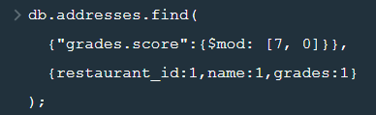

**{ _id: ObjectId("61e03803b3b8453f20344e95"),**

**grades:**

**[ { date: 2014-03-03T00:00:00.000Z, grade: 'A', score: 2 },**

**{ date: 2013-09-11T00:00:00.000Z, grade: 'A', score: 6 },**

**{ date: 2013-01-24T00:00:00.000Z, grade: 'A', score: 10 },**

**{ date: 2011-11-23T00:00:00.000Z, grade: 'A', score: 9 },**

**{ date: 2011-03-10T00:00:00.000Z, grade: 'B', score: 14 } ],**

**name: 'Morris Park Bake Shop',**

**restaurant_id: '30075445' }**

**{ _id: ObjectId("61e03803b3b8453f20344e98"),**

**grades:**

**[ { date: 2014-06-10T00:00:00.000Z, grade: 'A', score: 5 },**

**{ date: 2013-06-05T00:00:00.000Z, grade: 'A', score: 7 },**

**{ date: 2012-04-13T00:00:00.000Z, grade: 'A', score: 12 },**

**{ date: 2011-10-12T00:00:00.000Z, grade: 'A', score: 12 } ],**

**name: 'Riviera Caterer',**

**restaurant_id: '40356018' }**

**{ _id: ObjectId("61e03803b3b8453f20344e9a"),**

**grades:**

**[ { date: 2014-11-15T00:00:00.000Z, grade: 'Z', score: 38 },**

**{ date: 2014-05-02T00:00:00.000Z, grade: 'A', score: 10 },**

**{ date: 2013-03-02T00:00:00.000Z, grade: 'A', score: 7 },**

**{ date: 2012-02-10T00:00:00.000Z, grade: 'A', score: 13 } ],**

**name: 'Brunos On The Boulevard',**

**restaurant_id: '40356151' }**

**{ _id: ObjectId("61e03803b3b8453f20344ea1"),**

**grades:**

**[ { date: 2014-09-16T00:00:00.000Z, grade: 'B', score: 21 },**

**{ date: 2013-08-28T00:00:00.000Z, grade: 'A', score: 7 },**

**{ date: 2013-04-02T00:00:00.000Z, grade: 'C', score: 56 },**

**{ date: 2012-08-15T00:00:00.000Z, grade: 'B', score: 27 },**

**{ date: 2012-03-28T00:00:00.000Z, grade: 'B', score: 27 } ],**

**name: 'May May Kitchen',**

**restaurant_id: '40358429' }**

**{ _id: ObjectId("61e03803b3b8453f20344ea2"),**

**grades:**

**[ { date: 2014-05-07T00:00:00.000Z, grade: 'A', score: 3 },**

**{ date: 2013-05-03T00:00:00.000Z, grade: 'A', score: 4 },**

**{ date: 2012-04-30T00:00:00.000Z, grade: 'A', score: 6 },**

**{ date: 2011-12-27T00:00:00.000Z, grade: 'A', score: 0 } ],**

**name: '1 East 66Th Street Kitchen',**

**restaurant_id: '40359480' }**

**{ _id: ObjectId("61e03803b3b8453f20344ea3"),**

**grades:**

**[ { date: 2014-11-10T00:00:00.000Z, grade: 'A', score: 11 },**

**{ date: 2013-10-10T00:00:00.000Z, grade: 'A', score: 13 },**

**{ date: 2012-10-04T00:00:00.000Z, grade: 'A', score: 7 },**

**{ date: 2012-05-21T00:00:00.000Z, grade: 'A', score: 9 },**

**{ date: 2011-12-30T00:00:00.000Z, grade: 'B', score: 19 } ],**

**name: 'Seuda Foods',**

**restaurant_id: '40360045' }**

**{ _id: ObjectId("61e03803b3b8453f20344ea9"),**

**grades:**

**[ { date: 2014-08-16T00:00:00.000Z, grade: 'A', score: 12 },**

**{ date: 2013-08-27T00:00:00.000Z, grade: 'A', score: 9 },**

**{ date: 2012-09-20T00:00:00.000Z, grade: 'A', score: 7 },**

**{ date: 2011-09-29T00:00:00.000Z, grade: 'A', score: 10 } ],**

**name: 'Sal\'S Deli',**

**restaurant_id: '40361618' }**

**{ _id: ObjectId("61e03803b3b8453f20344eab"),**

**grades:**

**[ { date: 2014-03-19T00:00:00.000Z, grade: 'A', score: 3 },**

**{ date: 2013-03-13T00:00:00.000Z, grade: 'A', score: 12 },**

**{ date: 2012-03-27T00:00:00.000Z, grade: 'A', score: 8 },**

**{ date: 2011-04-05T00:00:00.000Z, grade: 'A', score: 7 } ],**

**name: 'Steve Chu\'S Deli & Grocery',**

**restaurant_id: '40361998' }**

**{ _id: ObjectId("61e03803b3b8453f20344eac"),**

**grades:**

**[ { date: 2014-09-15T00:00:00.000Z, grade: 'A', score: 10 },**

**{ date: 2014-03-04T00:00:00.000Z, grade: 'A', score: 13 },**

**{ date: 2013-07-18T00:00:00.000Z, grade: 'A', score: 13 },**

**{ date: 2013-01-09T00:00:00.000Z, grade: 'A', score: 11 },**

**{ date: 2012-04-10T00:00:00.000Z, grade: 'A', score: 10 },**

**{ date: 2011-11-15T00:00:00.000Z, grade: 'A', score: 7 } ],**

**name: 'Harriet\'S Kitchen',**

**restaurant_id: '40362098' }**

**{ _id: ObjectId("61e03803b3b8453f20344eaf"),**

**grades:**

**[ { date: 2014-03-18T00:00:00.000Z, grade: 'A', score: 8 },**

**{ date: 2013-03-18T00:00:00.000Z, grade: 'A', score: 8 },**

**{ date: 2012-10-10T00:00:00.000Z, grade: 'A', score: 7 },**

**{ date: 2011-09-22T00:00:00.000Z, grade: 'A', score: 2 } ],**

**name: 'White Castle',**

**restaurant_id: '40362344' }**

**{ _id: ObjectId("61e03803b3b8453f20344eb0"),**

**grades:**

**[ { date: 2014-04-21T00:00:00.000Z, grade: 'A', score: 10 },**

**{ date: 2013-11-12T00:00:00.000Z, grade: 'A', score: 5 },**

**{ date: 2013-06-04T00:00:00.000Z, grade: 'A', score: 12 },**

**{ date: 2012-11-14T00:00:00.000Z, grade: 'A', score: 10 },**

**{ date: 2012-10-11T00:00:00.000Z, grade: 'P', score: 0 },**

**{ date: 2012-05-24T00:00:00.000Z, grade: 'A', score: 13 },**

**{ date: 2011-12-08T00:00:00.000Z, grade: 'A', score: 12 },**

**{ date: 2011-07-20T00:00:00.000Z, grade: 'A', score: 11 } ],**

**name: 'Ho Mei Restaurant',**

**restaurant_id: '40362432' }**

**{ _id: ObjectId("61e03803b3b8453f20344eb2"),**

**grades:**

**[ { date: 2014-05-13T00:00:00.000Z, grade: 'A', score: 2 },**

**{ date: 2013-05-08T00:00:00.000Z, grade: 'A', score: 7 },**

**{ date: 2012-09-22T00:00:00.000Z, grade: 'A', score: 11 },**

**{ date: 2011-06-06T00:00:00.000Z, grade: 'A', score: 12 } ],**

**name: 'Shashemene Int\'L Restaura',**

**restaurant_id: '40362869' }**

**{ _id: ObjectId("61e03803b3b8453f20344eb7"),**

**grades:**

**[ { date: 2014-10-17T00:00:00.000Z, grade: 'A', score: 11 },**

**{ date: 2013-09-18T00:00:00.000Z, grade: 'A', score: 13 },**

**{ date: 2013-04-30T00:00:00.000Z, grade: 'A', score: 7 },**

**{ date: 2012-04-20T00:00:00.000Z, grade: 'A', score: 7 },**

**{ date: 2011-12-19T00:00:00.000Z, grade: 'A', score: 3 } ],**

**name: 'Olive\'S',**

**restaurant_id: '40363151' }**

**{ _id: ObjectId("61e03803b3b8453f20344ebb"),**

**grades:**

**[ { date: 2014-02-21T00:00:00.000Z, grade: 'A', score: 3 },**

**{ date: 2013-09-13T00:00:00.000Z, grade: 'A', score: 3 },**

**{ date: 2012-08-28T00:00:00.000Z, grade: 'A', score: 0 },**

**{ date: 2011-09-13T00:00:00.000Z, grade: 'A', score: 12 },**

**{ date: 2011-05-03T00:00:00.000Z, grade: 'A', score: 5 } ],**

**name: 'Lexler Deli',**

**restaurant_id: '40363426' }**

**{ _id: ObjectId("61e03803b3b8453f20344ebe"),**

**grades:**

**[ { date: 2014-02-25T00:00:00.000Z, grade: 'A', score: 7 },**

**{ date: 2013-08-14T00:00:00.000Z, grade: 'A', score: 11 },**

**{ date: 2012-08-07T00:00:00.000Z, grade: 'A', score: 7 },**

**{ date: 2012-03-26T00:00:00.000Z, grade: 'A', score: 10 },**

**{ date: 2011-11-04T00:00:00.000Z, grade: 'A', score: 0 },**

**{ date: 2011-06-29T00:00:00.000Z, grade: 'A', score: 4 } ],**

**name: 'Snack Time Grill',**

**restaurant_id: '40363590' }**

**{ _id: ObjectId("61e03803b3b8453f20344ebf"),**

**grades:**

**[ { date: 2014-06-02T00:00:00.000Z, grade: 'A', score: 9 },**

**{ date: 2013-12-27T00:00:00.000Z, grade: 'A', score: 8 },**

**{ date: 2013-03-18T00:00:00.000Z, grade: 'B', score: 26 },**

**{ date: 2012-02-01T00:00:00.000Z, grade: 'A', score: 7 },**

**{ date: 2011-07-06T00:00:00.000Z, grade: 'B', score: 25 } ],**

**name: 'Lorenzo & Maria\'S',**

**restaurant_id: '40363630' }**

**{ _id: ObjectId("61e03803b3b8453f20344ec0"),**

**grades:**

**[ { date: 2014-08-05T00:00:00.000Z, grade: 'A', score: 3 },**

**{ date: 2014-03-06T00:00:00.000Z, grade: 'A', score: 11 },**

**{ date: 2013-07-09T00:00:00.000Z, grade: 'A', score: 12 },**

**{ date: 2013-01-30T00:00:00.000Z, grade: 'A', score: 4 },**

**{ date: 2012-01-05T00:00:00.000Z, grade: 'A', score: 2 },**

**{ date: 2011-09-26T00:00:00.000Z, grade: 'A', score: 0 } ],**

**name: 'Domino\'S Pizza',**

**restaurant_id: '40363644' }**

**{ _id: ObjectId("61e03803b3b8453f20344ec2"),**

**grades:**

**[ { date: 2014-02-05T00:00:00.000Z, grade: 'A', score: 0 },**

**{ date: 2013-01-29T00:00:00.000Z, grade: 'A', score: 3 },**

**{ date: 2011-12-08T00:00:00.000Z, grade: 'A', score: 10 } ],**

**name: 'Sonny\'S Heros',**

**restaurant_id: '40363744' }**

**{ _id: ObjectId("61e03803b3b8453f20344ec9"),**

**grades:**

**[ { date: 2014-11-18T00:00:00.000Z, grade: 'A', score: 12 },**

**{ date: 2013-11-07T00:00:00.000Z, grade: 'A', score: 12 },**

**{ date: 2013-04-24T00:00:00.000Z, grade: 'A', score: 7 },**

**{ date: 2012-03-20T00:00:00.000Z, grade: 'A', score: 5 } ],**

**name: 'Plaza Bagels & Deli',**

**restaurant_id: '40364286' }**

**{ _id: ObjectId("61e03803b3b8453f20344ecc"),**

**grades:**

**[ { date: 2015-01-06T00:00:00.000Z, grade: 'A', score: 12 },**

**{ date: 2014-07-15T00:00:00.000Z, grade: 'C', score: 48 },**

**{ date: 2013-05-02T00:00:00.000Z, grade: 'A', score: 13 },**

**{ date: 2012-09-24T00:00:00.000Z, grade: 'A', score: 8 },**

**{ date: 2012-04-19T00:00:00.000Z, grade: 'A', score: 7 } ],**

**name: 'Texas Rotisserie',**

**restaurant_id: '40364304' }**

31. Write a MongoDB query to find the restaurant name, borough, longitude and attitude and cuisine for those restaurants which contains 'mon' as three letters somewhere in its name.

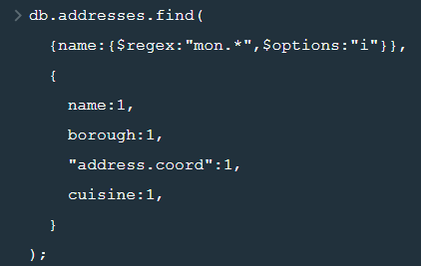

**{ _id: ObjectId("61e03803b3b8453f20344f29"),**

**address: { coord: [ -73.98306099999999, 40.7441419 ] },**

**borough: 'Manhattan',**

**cuisine: 'American ',**

**name: 'Desmond\'S Tavern' }**

**{ _id: ObjectId("61e03803b3b8453f20344f32"),**

**address: { coord: [ -73.8221418, 40.7272376 ] },**

**borough: 'Queens',**

**cuisine: 'Jewish/Kosher',**

**name: 'Shimons Kosher Pizza' }**

**{ _id: ObjectId("61e03803b3b8453f20344f3e"),**

**address: { coord: [ -74.10465599999999, 40.58834 ] },**

**borough: 'Staten Island',**

**cuisine: 'American ',**

**name: 'Richmond County Country Club' }**

**{ _id: ObjectId("61e03803b3b8453f20344f69"),**

**address: { coord: [ -73.9812843, 40.5947365 ] },**

**borough: 'Brooklyn',**

**cuisine: 'Pizza/Italian',**

**name: 'Lb Spumoni Gardens' }**

**{ _id: ObjectId("61e03803b3b8453f20344fbb"),**

**address: { coord: [ -73.951199, 40.7166026 ] },**

**borough: 'Brooklyn',**

**cuisine: 'Italian',**

**name: 'Bamonte\'S Restaurant' }**

**{ _id: ObjectId("61e03803b3b8453f20344ff2"),**

**address: { coord: [ -73.924072, 40.76108900000001 ] },**

**borough: 'Queens',**

**cuisine: 'Greek',**

**name: 'Omonia Cafe' }**

**{ _id: ObjectId("61e03803b3b8453f20345042"),**

**address: { coord: [ -74.0023353, 40.7333573 ] },**

**borough: 'Manhattan',**

**cuisine: 'American ',**

**name: 'Manhattan Monster' }**

**{ _id: ObjectId("61e03803b3b8453f2034506f"),**

**address: { coord: [ -74.001094, 40.729583 ] },**

**borough: 'Manhattan',**

**cuisine: 'Italian',**

**name: 'Monte\'S' }**

**{ _id: ObjectId("61e03803b3b8453f20345075"),**

**address: { coord: [ -73.9901605, 40.7526176 ] },**

**borough: 'Manhattan',**

**cuisine: 'American ',**

**name: 'Delmonico\'S Kitchen' }**

**{ _id: ObjectId("61e03803b3b8453f2034508b"),**

**address: { coord: [ -73.9979536, 40.6914024 ] },**

**borough: 'Brooklyn',**

**cuisine: 'Bottled beverages, including water, sodas, juices, etc.',**

**name: 'Montero Bar & Grill' }**

**{ _id: ObjectId("61e03803b3b8453f20345216"),**

**address: { coord: [ -73.9707505, 40.7635651 ] },**

**borough: 'Manhattan',**

**cuisine: 'Delicatessen',**

**name: 'Delmonico Gourmet' }**

**{ _id: ObjectId("61e03804b3b8453f20345283"),**

**address: { coord: [ -73.9760637, 40.7508686 ] },**

**borough: 'Manhattan',**

**cuisine: 'American ',**

**name: 'Delmonico Gourmet' }**

**{ _id: ObjectId("61e03804b3b8453f20345297"),**

**address: { coord: [ -73.9705633, 40.7605759 ] },**

**borough: 'Manhattan',**

**cuisine: 'Italian',**

**name: 'Montebello Restaurant' }**

**{ _id: ObjectId("61e03804b3b8453f2034532f"),**

**address: { coord: [ -74.1914658, 40.55274360000001 ] },**

**borough: 'Staten Island',**

**cuisine: 'Italian',**

**name: 'Villa Monte Pizzeria' }**

**{ _id: ObjectId("61e03804b3b8453f203453da"),**

**address: { coord: [ -73.97198209999999, 40.764464 ] },**

**borough: 'Manhattan',**

**cuisine: 'American ',**

**name: 'Harmonie Club' }**

**{ _id: ObjectId("61e03804b3b8453f2034549e"),**

**address: { coord: [ -73.79571990000001, 40.7095637 ] },**

**borough: 'Queens',**

**cuisine: 'Bakery',**

**name: 'Ramona\'S Bakery' }**

**{ _id: ObjectId("61e03804b3b8453f203454d2"),**

**address: { coord: [ -73.97852100000001, 40.729192 ] },**

**borough: 'Manhattan',**

**cuisine: 'American ',**

**name: 'Mona\'S' }**

**{ _id: ObjectId("61e03804b3b8453f203454f7"),**

**address: { coord: [ -73.98463480000001, 40.7630755 ] },**

**borough: 'Manhattan',**

**cuisine: 'American ',**

**name: 'Neil Simon Theatre' }**

**{ _id: ObjectId("61e03804b3b8453f20345532"),**

**address: { coord: [ -73.9938361, 40.6091317 ] },**

**borough: 'Brooklyn',**

**cuisine: 'Bakery',**

**name: 'Mondial Bakery' }**

**{ _id: ObjectId("61e03804b3b8453f20345559"),**

**address: { coord: [ -74.028486, 40.630438 ] },**

**borough: 'Brooklyn',**

**cuisine: 'Mediterranean',**

**name: 'Omonia Cafe'** }

32. Write a MongoDB query to find the restaurant name, borough, longitude and latitude and cuisine for those restaurants which contain 'Mad' as first three letters of its name.

